**EEB Prep**

**P.s. (Underline keywords in your answers)**

EEB:

- Business plan

- Types of entrepreneurs/organisations (llc, etc)

- Competition analysis/marketing analysis

- Real life applications of venture planning

**Mod 1:- Introduction**

1. **Definition of Entrepreneur:**

The entrepreneur word is derived from the French word Entreprendre which means to undertake, i.e., the person who is ready to accept the challenges, risks, whatever will come to his way while starting a new business.

According to Oxford Dictionary an entrepreneur is “A person who sets up a business or businesses, taking on financial risks in the hope of profit”

According to the International Encyclopedia, an entrepreneur is “An individual who bears the risk of operating a business in the face of uncertainty about the future conditions”.

1. Schumpeter’s Definition: “The entrepreneur, in an advanced economy is an individual who introduces something new in the economy.
2. Adam Smith’s Definition: “The entrepreneur is an individual, who forms an organization for commercial purpose. She/he is proprietary capitalist, a supplier of capital and at the same time a manager who intervenes between the labour and the consumer”.
3. Peter F. Drucker’s Views on Entrepreneur: “An entrepreneur is the one who always searches for change, responds to it and exploits it as an opportunity.
4. Innovation is the specific tool of entrepreneurs, the means by which they exploit changes as an opportunity for a different business or different service”.
5. **Characteristics of Successful Entrepreneurs:**

* Self-Confident and Optimistic
* Able to take calculated risk
* Respond positively to challenges
* Flexible and able to adapt
* Knowledgeable of markets
* Able to get along well with others
* Independent Minded
* Versatile Knowledge
* Energetic and Diligent
* Creative, need to achieve
* Dynamic Leader
* Responsive to suggestions
* Take initiatives
* Resourceful and Persevering
* Perceptive with foresight
* Responsive to criticism

1. **What is entrepreneurship ?**

Entrepreneurship is the **dynamic process of creating incremental wealth**. This wealth is created by individuals who **assume major risks in terms of equity, time, and/or career commitment** of providing value for some **product or service**. The product or service itself **may or may not be new or unique** but value must somehow be infused by the entrepreneur by securing and **allocating the necessary skills and resources.**

through the communicative and management skills to mobilize:

* **human,**
* **financial,**
* **managerial**
* **material resources necessary to bring the project to fruition.**

Entrepreneurship means:

* the function of seeing investment and production process,
* raising capital,
* hiring labor,
* arranging the supply of raw materials,
* finding site,
* introducing a new technique and commodities,
* discovering new sources of raw materials, and
* selecting top managers for day-to-day operations of the enterprise.

Entrepreneurship involves a wide range of **areas needing a series of decisions** that can be broadly grouped into three categories –Decisions related to-

* **Perception of an opportunity**,
* **Organization of an industrial unit**, and
* **Running of the industrial unit as a profitable**, going, and growing concern.

1. **Process of Entrepreneurship**

The Entrepreneurship Process can be expressed as a set of procedures and methodologies, followed by entrepreneurs to establish a new business or venture. All the entrepreneurship process phases have certain meanings and functionality, which one has to trail and pursue for setting up a venture.

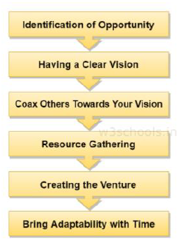

**Identification of Opportunity**

* An entrepreneur has to detect a problem in society and sense some opportunities and visualize the market or consumer ratio.
* Entrepreneurs should look for the scope to find an alternate efficient solution for needs, wants, detecting issues and problems, and effective solutions.
* His/her creativity and innovation will also bring challenges.
* If an entrepreneur is opting for the solution then he is on the advantageous side, which provides product identification and top reliability in the market.
* Eg- ID Fresh food, Swiggy, Zomato, Pink Auto(govt initiative), Bookmynanny,etc.

**Having a Clear Vision**

* There’s a say ”A vision without implementation is just a dream with closed eyes.”
* An entrepreneur must have to see while creating his empire to look beyond the idea or plan.
* He/she has to have a vision from the experience and a creative mindset to come up with new and innovative methodologies for solving different problems.
* Example, Mark Zuckerberg, Elon Musk, etc.

**Coax others towards your vision**

* An entrepreneur has to form a team with different skill-sets who will work together to make the vision a reality.
* As an entrepreneur, he/she has to persuade all those individuals (partners, family members, financiers, employees) towards the same goals and motives.

**Resource Gathering**

* An entrepreneur has to come up with a strong business plan and a powerful pitching capability to make your audience understand the potential in your idea.
* Your business plan should also attract venture capitalists, investors, different financial institutions, partners, and promoters.
* After getting financial support, the entrepreneur has to identify resources (which can be materials, office location, or workforce) to turn their ideas into a viable enterprise.

**Creating the venture**

* After all the resources are in the proper place and arranged, it is time to develop the venture and start running it successfully.
* This requires most of the skills that an entrepreneur should possess.

**Bring adaptability with time**

* It is essential to monitor and realize when the upgradation is necessary for an organization.
* Because if you do not keep bringing enhanced things on the table, someone else will take away the market and hence the profit. Ex -Kodak film
* The entrepreneurs only have to think out of the box and adapt to the changing market conditions.
* Example, Mark Zuckerberg using AIML after creating facebook

1. **What is the Importance of Entrepreneurship in Economic Development?**

Development of a sound industrial sector can play an important role for all-round development of a country.

The role of Entrepreneurship for economic development is very beneficial for our country.

**Generates Employment:**

* Entrepreneurs play a vital role in getting employment for themselves as well as they create a number of jobs for many unemployed people.
* As time passes, these entrepreneurs grow manifold and provide direct and indirect employment to many more.
* Entrepreneurship is the best solution to solve the social problem of unemployment.

**Increases National Income:**

* The increased number of Entrepreneurs meet the domestic demand and export demand by producing goods and services in the desired quantities.
* Therefore, an increase in goods and services helps in increasing the national income of a country, increase in goods and services helps in increasing the national income of a country.
* Increased employment will contribute to the generation of higher National Income.

**Increases possibility for Dispersal of Economic Power**

* Economic power is the natural outcome of Industrial and business activity.
* Industrial development normally leads to concentration of economic power in a few hands,which leads to Monopoly.
* The conditions of monopoly in the country shall lead to a number of social and economic evils -like increase in price of the product and services and adamancy.. etc…
* Hence the encouragement given by the Government to new Entrepreneursto set up a large number of enterprises helps in weakening the harmful effects of monopoly.
* When the concentration of Economic Power in a few hands has been removed and wealth shared by a large number of Entrepreneurs, socialism can be promoted, and the Nation shall become economically wealthy.

**Leads to Balanced Regional Growth**

* The growth of Industry and Business leads to the development of a number of other areas such as transportation, health, education, insurance, warehousing etc. hence a rapid development of Entrepreneurship ensures a balanced regional development.
* If the new Entrepreneurs grow at a faster rate in view of increasing competition, the surrounding areas are developed due to the spreading of entrepreneurial activities to other areas. Therefore, setting up enterprises in smaller towns which are away from big cities/towns helps in the development of backward regions also.

**Provides better Standard of Living**

* In any Economy, the people desire to get the goods and services in the required quantities at required places to satisfy their needs and wants.
* The Entrepreneurial activities lead to the establishment of micro, small, medium, and large scale enterprises in all regions of the country. The scarcity of essential commodities is removed with the initiation of entrepreneurial activities.
* All the Entrepreneurs lead to improvement in the standard of living of the people.Hence providing goods and services in required quantities at a lower price, improves the purchasing power and standard of living of the people.

**Production of Qualitative Goods**

* The increased Entrepreneurial undertakings ensure newer and qualitative products to the consumers, the Entrepreneurs in order to face the competition of the market and to satisfy the desires of consumers.
* They concentrate on improved methods of production, quality of the product, reasonableness in price, effective distribution, etc.hence the quality of the product and services provided by the Entrepreneurs ensures the good health of the consumer.

**Increasing Income Levels**

* The increased Entrepreneurial activities lead to higher income levels and purchasing power of the people.
* The Entrepreneur’s Industrial activities provide an increase in direct or indirect income levels to many people, the income levels of the people are increased
  + Owing to the availability of goods at lower prices,
  + Or generation of direct or indirect employment,
  + Promotion of comforts,
  + The establishment of infrastructural facilities etc.

**Helps in Exports**

* The increased Entrepreneurial activities not only provide the required goods and services to the people, but it is also for expanding the surplus production of the Nation to other countries.
* It means that the country shall become self-sufficient and can earn foreign exchange also with exporting of surplus goods and services.

**Generates Capital**

* Increased Entrepreneurial activities help in generating scarce capital.
* The Entrepreneur acts as a middleman between investors and enterprise and raises capital from various sources.
* The capital raised is used for setting up a new business for creating goods and services to satisfy the consumer needs and wants, the high growth rate of capital formation indicates the Economic development of a Country.

**Effective Utilization of Natural Resources**

* A Country’s Economic development always depends on the Utilisation of its Natural Resources. Availability of natural resources differsfrom one region to other regions. When available resources such as climate, soil, rainfall, mineral mines, sources of power and gas etc.are effectively used, the economy is assured of rapid growth and development of a country.

**Creation of Markets**

* Entrepreneurial activities lead to increased production of goods and services.
* This automatically leads to the creation of new markets and new customersfor the new enterprise.
* Thus, a new enterprise creates a new market for the goods and services and capture a market sharein the business.

**Enhances Per Capita Income**

* The per capita income of a country is equal to national income divided by its population. The availability of goods and services produced by Entrepreneurs leads to an increase in national income which in turn increases per capita income of the people.
* The increased per capita income reflects the Economic Growth and Industrialization of an economy.
* Formula

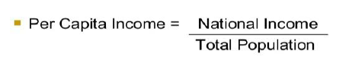

**Makes the country Self-Reliant**

* The Entrepreneurial activities of Entrepreneurs enable the country to be self-reliant. It reduces the dependence on imports and increases exports.
* Therefore, our country becomes self-reliant by producing goods and services required by society.
* The reduced dependence on foreign countries and their produce indicates a strong balance of payments for our country.

**Leads to innovations**

* Entrepreneurial activities lead to employing resources on new ideas and innovations. The Entrepreneurs locate new ideas and put them into effect in the process of Economic Development.
* The Entrepreneur is an innovator of new ideas of products and services.
* They are capable of satisfying the dynamic needs of Society, like generating Employment Opportunities.

1. **Classification and types of Entrepreneurs.**

Based on the Type of Business:

1. Trading Entrepreneur:

* They procure the finished products from the manufacturers and sell these to the customers directly or through a retailer.
* These serve as the middlemen as wholesalers, dealers, and retailers between the manufacturers and customers.

1. Manufacturing Entrepreneur:

* They identify the needs of the customers and, then, explore the resources and technology to be used to manufacture the products to satisfy the customers’ needs.
* In other words, the manufacturing entrepreneurs convert raw materials into finished products.

1. Agricultural Entrepreneur:

* The entrepreneurs who undertake agricultural pursuits are called agricultural entrepreneurs.
* They cover a wide spectrum of agricultural activities like cultivation, marketing of agricultural produce, irrigation, mechanization, and technology.

1. Corporate Entrepreneurs:

* These entrepreneurs promote and establish corporate empires. They are successful at initiating and running corporate companies

Based on the Use of Technology:

1. Technical Entrepreneur:

* The entrepreneurs who establish and run science and technology-based industries are called ‘technical entrepreneurs.’
* Expectedly, they use new and innovative methods of production in their enterprises.

1. Non-Technical Entrepreneur:

* The forte of their enterprises is not science and technology.
* They are concerned with the use of alternative and imitative methods of marketing and distribution strategies to make their business survive and thrive in the competitive market.

Based on Ownership:

1. Private Entrepreneur:

* A private entrepreneur is one who as an individual sets up a business enterprise. He / she it’s the sole owner of the enterprise and bears the entire risk involved in it.

1. State Entrepreneur:

* When the trading or industrial venture is undertaken by the State or the Government, it is called ‘state entrepreneur.’

1. Joint Entrepreneurs:

* When a private entrepreneur and the Government jointly run a business enterprise, it is called ‘joint entrepreneurs.’

Based on the Size of Enterprise:

1. Small-Scale Entrepreneur:

* An entrepreneur who has made investment in plant and machinery up to Rs 1.00 crore is called ‘small-scale entrepreneur.’

1. Medium-Scale Entrepreneur:

* The entrepreneur who has made investment in plant and machinery above Rs 1.00 crore but below Rs 5.00 crore is called ‘medium-scale entrepreneur.’

1. Large-Scale entrepreneur:

* The entrepreneur who has made investment in plant and machinery more than Rs 5.00 crore is called ‘large-scale entrepreneur.’

Based on Clarence Danhof Classification:

1. Innovating Entrepreneurs: who introduce new goods, inaugurate new method of production, discover new market and reorganise the enterprise.
2. Imitative Entrepreneurs: do not innovate the changes themselves, they only imitate techniques and technology innovated by others.
3. Fabian Entrepreneurs: Fabian entrepreneurs are characterised by very great caution and skepticism in experimenting any change in their enterprises.

They imitate only when it becomes perfectly clear that failure to do so would result in a loss of the relative position in the enterprise.

1. Drone Entrepreneurs: These are characterised by a refusal to adopt opportunities to make changes in production formulae even at the cost of severely reduced returns relative to other like producers.

Such entrepreneurs may even suffer from losses but they are not ready to make changes in their existing production methods.

Arthur Harrison. Cole Classification:

1. Empirical – rarely introduce anything radical, innovative or revolutionary.
2. Rational – They understand the prevailing economic conditions and are ready to introduce modifications when necessary.
3. Cognitive – They have experts to advise them and acts upon accordingly.

They introduce changes whenever necessary .

These changes may completely break from the existing scheme of enterprise.

1. **Corporate Social Entrepreneurship (CSE) [ Include all the topics after this from the ppt in this answer only]**

Corporate Social Entrepreneurship (CSE) is a process aimed at enabling business to develop more advanced and powerful forms of Corporate Social Responsibility (CSR).

CSE aims to produce a significant and comprehensive transformation of the way a company operates.

The following elements are central to that process:

* creating an enabling environment:
  + For companies to move from their old approach to CSR to the CSE approach they must adopt an entrepreneurial mindset and cultivate an entrepreneurial environment that enables fundamental organizational transformation.
  + This can only happen if top leadership champions the change.
  + This requires a powerful vision of where the CSR revolution is taking the company and why it is vital to the organization’s success.
* fostering corporate social intrapreneurs:
  + The CSE process is powered by multiple change agents or Intrapreneurs.
  + Social and corporate entrepreneurship differentiate the roles of the social or corporate entrepreneur from the role of managers.
  + Both are distinct and usually sequenced:
* amplifying corporate purpose and values:
  + One of the key focal points of CSE is company values.
  + Getting organizational values right is vital to advancing CSR.
  + The CS Intrapreneurs need to ensure that social value generation – fulfilling social responsibilities – is seen as an essential component in companies’ mission and values statements.
  + The CSE process aims to ensure that the words are translated into action.
* Generating double value, building strategic alliances:
  + Entrepreneurship is all about finding innovative ways to create value.
  + CSE aims to ensure that the very purpose of these corporations migrates from one of maximizing returns to investors to optimizing returns to stakeholders, with those being defined as groups who are significantly affected by company actions and who can in turn impact the company.

**Mod 2:- Entrepreneurship Development and Leadership**

**Q1) Entrepreneurial Motivation: motivating factors/Factors influencing entrepreneurial development and motivation**

Many researchers have tried to understand and answer this question by conducting research studies to identify the factors that motivate people to take all the risk and start a business enterprise. While some researchers have classified the factors motivating entrepreneurs into ‘push’ (compulsion) and ‘pull’ (choice) factors, ● most of the researchers have classified all the factors motivating entrepreneurs into internal and external factors:

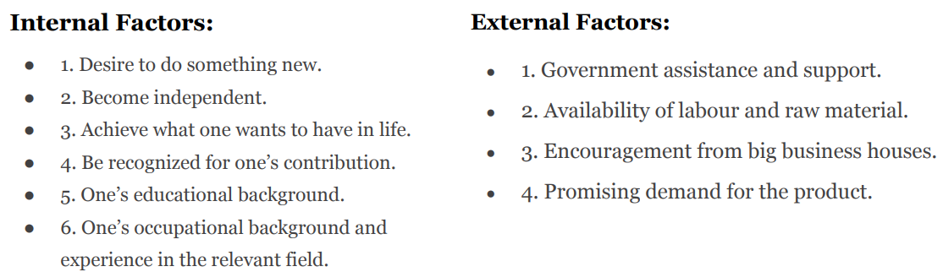

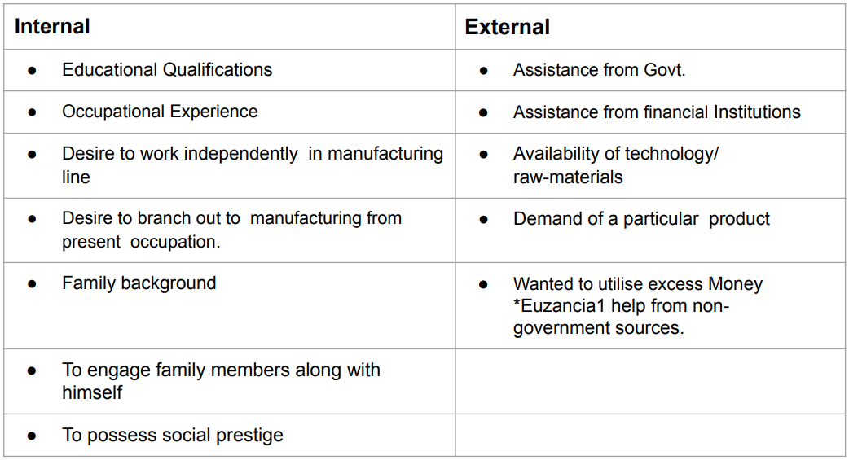

**Q2) Types of startups**

**Startup Type 1: Scalable Startups**

* Scalable startups take an idea or concept — typically in the tech sphere — and work to rapidly grow the company’s top-end revenue to achieve the highest return on investment (ROI) possible. This type of startup requires thorough market research to identify exploitable market opportunities.
* Two of the most relevant examples of scalable startups are Google and Facebook. Both of these companies started with the intent to dominate their industry through a scalable startup model and were successful in doing so.

A Scalable Startup May Be Right for You If:

* Your startup idea has an extensive market available and vast growth potential.
* You’re an innovator ready to challenge the status quo.
* You want to be the leader of an industry.

Example- 1. Facebook 2. Twitter 3. Instagram 4. Google, 5. Skype

**Startup Type 2: Large Company Startups**

With technology, customer interest, and markets changing every day, large companies need to adapt their business model to survive. This is where large company startups come in. Backed by the support and capital of the already successful company, these offshoot startups aim -

* to reach new audiences,
* diversify product offerings, and
* keep large companies tapped into the ever-changing market.

A Large Company Startup May Be Right for You If:

* You already own a large, successful company.
* You’re looking to diversify or tap into a new market that isn’t in your company’s current wheelhouse.
* You need a way to compete with new businesses and keep up with the changing market.

Example- Google's parent company, Alphabet Inc., has numerous subsidiary startups like Waymo (self-driving cars) and Verily (healthcare technology).

**Startup Type 3: Small Business Startups**

The priority of small business startups is longevity instead of scalability. ●These small startup companies are built to provide enough capital for financial stability by catering to a small target market. Common types of small business startups are family-owned and operated barbershops, grocery stores, and retail shops.

A Small Business Startup May Be Right for You If:

● You plan to hire locals and family to operate your business.

● You want to focus on adding to your community.

● Creating a sustainable, long-lasting business is your main focus, rather than pure profit.

Example: A neighborhood bakery, a local accounting firm, or a boutique clothing store can be considered small business startups.(gpt eg)

**Startup Type 4: Social Entrepreneurship Startups**

Unlike other types of startups, social startups are not created to gain wealth for the founders; They are created to make a positive social or environmental change.

Social entrepreneurs shouldn’t expect a big payout from their startup; however, it is possible to make money with this startup model if it is not a nonprofit organization.

A Social Entrepreneurship Startup May Be Right for You If:

● You want to build a company that will make a positive social or environmental impact.

● You aren’t interested in starting a company for the profit.

● You have an idea that can solve a widespread problem, specifically for disadvantaged communities

Example: Goonj is a well-known Indian social entrepreneurship startup. It focuses on addressing clothing and other basic needs for underprivileged communities while promoting sustainable development.(gpt eg)

**Startup Type 5: Lifestyle Startups**

Lifestyle startups are born out of passion and desire for independence, with the founders putting their time and energy toward making a business out of their favorite hobby or activity. This can range from an avid traveler starting a tour guide business to a web developer starting a freelance coding business.

A Lifestyle Startup May Be Right for You If:

● You have a hobby you could do all day, every day.

● You’re self-motivated and disciplined enough to be your own boss.

● You’re passionate and creative.

Example: Lifestyle businesses encompass professional blogging, freelance writing (novelists, poets, journalists), consultancy services, and online stores, all providing individuals with the flexibility to pursue their passions while earning a living.

**Startup Type 6: Buyable Startups**

Unlike other startups, buyable startups are not built to become billion-dollar companies; alternatively, they are built to be sold to a larger company for millions of dollars. Buyable startups are commonly tech-focused, and many of them are specifically in the app development industry.

A Buyable Startup May Be Right for You If:

● You want to build a company but not commit to operating it long-term.

● You have a startup idea with tremendous growth potential.

● You’re a “serial entrepreneur.”

Example: Instagram, which was acquired by Facebook, started as a buyable startup due to its unique photo-sharing platform.

**Q3) Characteristics of entrepreneurial leadership/Components of Entrepreneurial Leadership**:

**1. Communication skills**

● The leader is able to clearly articulate their ideas, and the plan to achieve common

goals.

● They encourage communication between departments and across levels.

● They avoid ambiguities and generalizations, and are able to avoid conflict and

misunderstanding due to poor communication.

Eg- Microsoft

**2. Vision**

● A successful entrepreneurial leader has a clear vision.

● He knows exactly where he wants to go and how to get there.

● They communicate their vision to the team and work with them to make the vision a

reality.

**3. Supportive - Ratan Tata**

● An entrepreneurial leader realizes the importance of initiative and reactiveness, and

they go out of their way to provide all the support that the team needs to achieve their

goals.

● The leader usually does not punish employees when they take a calculated risk which

misfires.

● Instead, they sit down with employees to analyze what went wrong and work with

them to correct the mistakes.

**4. Self-belief**

● The leader has tremendous belief in themselves and has confidence gained from years of experimenting, at times failing, and learning.

● They are aware of their strengths and weaknesses, and demonstrate their skills

without hubris.

● An entrepreneurial leader is very self-assured.

**5. Shares success - Former President Dr.A.P. J. Abdul Kalamji**

● When the team or the organization succeeds at something, the leader does not hog the limelight or take all the credit.

● They acknowledge the contribution of others and shares the accolades with them.

**6. Involved - Ratan Tata ji / Narayan Moorthy**

● You will not find an entrepreneurial leader cooped up in the office.

● Leaders like to spend time among employees, walk around the factory or department, interact with everyone, and see them doing their job.

● This leader will usually take some time out to informally chat with employees, and understand their work and personal challenges.

**7. Create an atmosphere conducive to growth - Google office**

● With a deep understanding of the importance of other people’s contribution to organizational success, the entrepreneurial leader creates an atmosphere that encourages everyone to share ideas, grow, and thrive.

● They actively seek other’s opinions, and encourages them to come up with solutions to the problems that they face.

● The entrepreneurial leader also provides positive feedback when employees come forward with an opinion.

**8. Honesty - Narayan Moorthy - Ratan Tata Ji**

● Honesty is the most important quality of an exceptional leader.

● Entrepreneurial leaders who are honest are able to quickly win the trust of their

employees.

● People respect leaders to come across as honest, and are more likely to accept positive or negative feedback and also work harder.

**9. Perseverance**

● When the going gets tough, the entrepreneurial leader perseveres. True entrepreneurs

simply don’t quit, they keep going till they find what they’re looking for.

**10. Learning**

● The leader not only invests significantly in learning and updating their knowledge, but they also create a learning environment in the organization encouraging others to improve their knowledge, widen their experience, and tackle multiple challenges.

● They encourage employees to think outside the box and come up with creative solutions to problems.

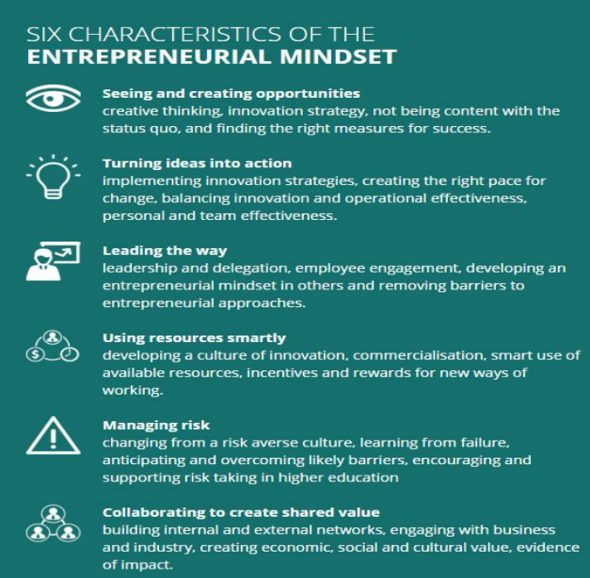

Additional points GPT

* Resourcefulness and Problem-Solving: Entrepreneurial leaders are adept at finding and utilizing resources efficiently. They excel in solving complex problems and making the most of available assets.
* Decisiveness and Action-Oriented: They make quick and informed decisions, often with limited information. They prioritize action and execution, avoiding over-analysis or indecision.
* Team Building and Empowerment: Entrepreneurial leaders build strong teams and empower their members to take ownership and contribute to the company's success. They foster a culture of collaboration and innovation.
* Networking and Relationships: Entrepreneurial leaders actively network and build relationships with key stakeholders, including investors, mentors, customers, and industry peers, to gain support and insights.

**Q4) Factors influencing entrepreneurial development and motivation,**

(GPT ans just for ref)

Entrepreneurial development and motivation are influenced by:

1. Personal Traits: Including risk tolerance, passion, and resilience.

2. Education and Experience: Such as relevant training and work background.

3. Access to Resources: Including financial capital and human capital.

4. Support Systems: Like mentorship, networking, and social support.

5. Market Opportunities: Identifying needs and market trends.

6. Government Policies: Such as tax incentives and business regulations.

7. Cultural and Social Factors: Including societal attitudes and role models.

8. Economic Conditions: Stability and market demand.

9. Technological Advancements: Access to technology.

10. Global Trends: Such as globalization and digitalization.

**Q5) Entrepreneurial Opportunities and challenges, Entrepreneurship process.**

**GPT**

Entrepreneurial Opportunities and Challenges:

Entrepreneurial opportunities refer to favorable circumstances or gaps in the market that entrepreneurs identify and leverage to create new ventures. These opportunities can stem from emerging trends, unmet needs, technological advancements, or changes in consumer behavior. Capitalizing on these opportunities can lead to business success, but entrepreneurs also face several challenges:

**1. Market Research:** Identifying viable opportunities requires thorough market research to understand customer needs, competition, and potential demand.

**2. Resource Acquisition:** Securing the necessary resources, including capital, talent, and technology, can be challenging, especially for new entrepreneurs.

**3. Risk Management:** Entrepreneurship involves inherent risks, such as financial losses and uncertainty. Managing and mitigating these risks is crucial.

**4. Adaptation:** The business environment is dynamic, and entrepreneurs must adapt to changing market conditions and consumer preferences.

**5. Scaling:** As a venture grows, scaling operations while maintaining quality and profitability can be a significant challenge.

**Entrepreneurship Process: can refer M1 Q4**

The entrepreneurship process is the sequence of steps an individual takes to turn an idea or opportunity into a viable and sustainable business. It typically involves the following stages:

**1. Idea Generation:** This stage involves brainstorming and identifying potential business ideas or opportunities.

**2. Market Research:** Entrepreneurs conduct market research to validate their ideas, understand customer needs, and assess the competitive landscape.

**3. Business Planning:** Entrepreneurs create a detailed business plan that outlines their strategy, goals, financial projections, and operational plans.

**4. Resource Acquisition:** Securing funding, hiring talent, and acquiring necessary resources are critical steps in launching the venture.

**5. Business Launch:** The venture is officially launched, and operations begin, including product development, marketing, and sales efforts.

**6. Growth and Scaling:** As the business gains traction, entrepreneurs focus on scaling operations, expanding market reach, and increasing profitability.

**7. Continuous Innovation:** Successful entrepreneurs continuously innovate to stay competitive, adapt to market changes, and meet evolving customer needs.

**8. Risk Management:** Throughout the process, entrepreneurs manage risks, both internal and external, to ensure the business's sustainability.

**9. Exit Strategy:** Some entrepreneurs plan for an exit strategy, which may involve selling the business, going public, or passing it on to successors.

**Q6) Types of Enterprises and Ownership Structure: small scale, medium scale and large-scale enterprises: Meaning and definition (evolution), role of small enterprises in economic development;**

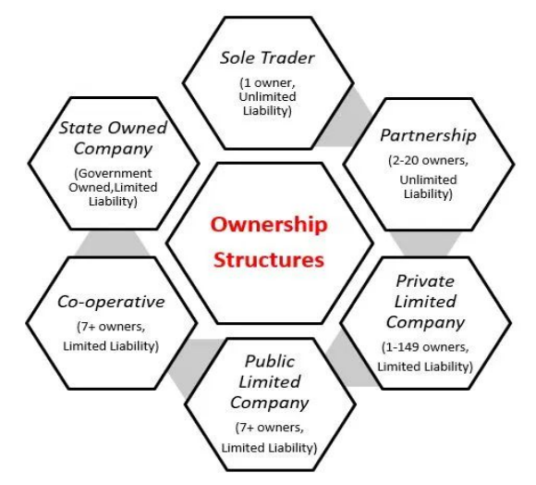

Based on

1. No of owner

2. Control over the business

3. Taxation

4. Liability

5. Finance

6. Legal status

7. Profit and loss

8. Risk

proprietorship, Policies governing SMEs, partnership, Ltd. companies and co-operatives: their formation, capital structure and source of finance.

**1. Sole Proprietorship**

● default structure of a business that hasn’t filed any paperwork to create a legal entity.

● It is the simplest form of business ownership, and the structure of choice for four out of five small business owners with no employees.

**Advantages of a sole proprietorship**

Sole proprietorship is a simple ownership type with several advantages, including the following:

**● Simplicity:**

a. In most cases, sole proprietors operating under their own names can simply get to work without filing paperwork with the state.

b. Sole proprietorships may be exempt from certain licensing and registration requirements such as obtaining a business license to sell online.

c. This makes sole proprietorship the simplest and least expensive among the different types of business ownership.

**● Control over the business:**

a. A sole proprietorship is owned by a single person.

b. There’s no need to get consensus before making decisions about the business: It’s all yours.

● **Pass-through taxation:**

Profits from a sole proprietorship pass through to the owner’s personal income, simplifying taxes significantly.

**Disadvantages of a sole proprietorship**

Sole proprietorships do have their disadvantages compared to other types of ownership.

**● Legal liability:**

a. A sole proprietorship passes more than income through to its owner.

b. Legally, the two are inseparable.

c. That means any lawsuits or other claims against the business are launched personally against the owner.

d. As a sole proprietor, you’re putting your personal assets on the line every day that you operate your business.

**● Financial risk:**

a. In addition to legal risks, sole proprietors take on all financial risk of the business personally.

b. Your home, bank accounts, cars, and other assets can be seized to satisfy claims by creditors if your business hits a rough patch financially.

**● Access to funding:**

a. Because of their informal structures, sole proprietorships generally have a harder time accessing loans and investment capital than other business ownership types.

b. This can make it difficult to provide competitive benefits such as small business health insurance.

**2. Partnerships**

Partnerships, often called general partnerships, are businesses with more than one owner. If you team up on a business venture without forming a legal business entity through the state, your business is a partnership by default.

● While they don’t require formation paperwork, there may be limitations on naming a partnership in your state, which may necessitate filing a “doing business as” (DBA) name.

● Partnerships are usually founded on formal partnership agreements outlining the ownership share, rights, and obligations of each partner. Partnerships are a popular type of company ownership for professional firms.

**Advantages of a partnership**

Partnerships provide some notable advantages, including:

**● Simplicity:**

Partnership is a relatively simple structure since it doesn’t require formation paperwork. Depending on the number of partners and the terms of your agreement, they can also be relatively simple to run.

**● Pass-through taxation:**

Partnerships are pass-through entities, with income passing through to partners proportionally based on share of ownership. If your partnership is split evenly down the middle, for example, 50% of the business’s profits would pass through to each partner’s personal income. Partnerships qualify for the 20% QBI deduction.

**● Control over the business:**

Partnerships allow their owners to participate in the business directly and allocate profits and control according to their own wishes. New partners can be brought in relatively easily.

**Disadvantages of a partnership**

Following are some drawbacks of partnerships:

**● Legal liability:**

Like sole proprietorships, partnerships open the partners up to legal liability for the firm’s operations. Liability insurance can address these risks, but insurance has limits.

**● Financial risk:**

Partners also take on financial liability for the business, putting their personal assets at risk in case of financial hardship or bankruptcy.

**3. Public Company**

A Public Limited Company under Company Act 2013 is a company that has limited liability and offers shares to the general public. Its stock can be acquired by anyone, either privately through (IPO) initial public offering or via trades on the stock market.

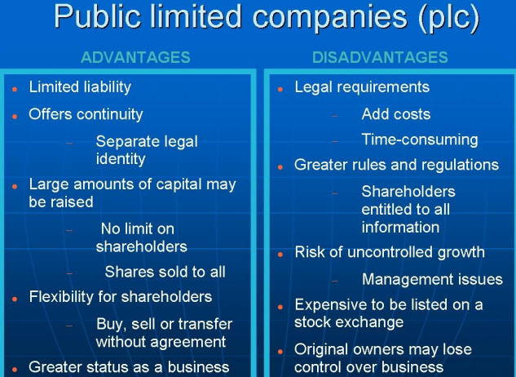

**4. Private limited company**

A Private Limited Company is formed lawfully with Limited Liability or Legal Protection for its shareholders but that places restrictions on its ownership. A private limited company is a privately-held business entity.

● It is held by private stakeholders.

●The liability arrangement in these is that of a limited partnership, wherein the liability of a shareholder extends only up to the number of shares held by them.

● Private Limited Company is the simplest and a very popular form of Business Registration in India. It can be registered with a minimum of two people.

● Following points make it the most recommended type of business entity for millions of small and medium-sized businesses that are family owned or professionally managed.

○ Limited liability protection to shareholders,

○ ability to raise equity funds,

○ separate legal entity status

**Advantages of Private Limited Company**

**● No Minimum Capital:**

No minimum capital is required to form a Private Limited Company. A Private Limited Company can be registered with a mere sum of Rs. 10,000 as total Authorized Share capital.

**● Separate Legal Entity:**

A Private Limited Company is a separate legal identity in the court of the law, meaning assets and liabilities of the business are not the same as the assets and liabilities of the Directors. Both are counted as different. A Private Limited Company separates Management and Ownership and thus, managers are responsible for the company’s success and are also answerable for the company’s loss.

**● Limited Liability:**

If the company undergoes financial distress because of whatsoever reasons, the personal assets of members will not be used to pay the debts of the Company as the liability of the person is limited. For e.g. If a Private Limited Company takes any loan and is unable to pay off, the members are responsible to pay only that much how much they own towards their own shareholding i.e. the unpaid share value. Which means, if you have no balance payable towards the amount of shares you hold, you are not payable towards any debt payable by the company even if the debt/credit amount remains unpaid.

**● Fund Raising:**

A Private Limited Company in India is the only form of business except Public Limited Companies that can raise funds from the Venture Capitalists or Angel investors.

**● Free & Easy transfer of shares:**

Shares of a company limited by shares are transferable by a shareholder at any other person. The transfer is easy as compared to the transfer of an interest in a business run as a proprietary concern or a partnership. Filing and signing a share transfer form and handing over the buyer of the shares along with share certificate can easily transfer shares.

**● Uninterrupted existence:**

A Private Limited Company has ‘Perpetual Succession’, that is continued or uninterrupted existence until it is legally dissolved. A company, being a separate legal person, is unaffected by the death or other departure of any member but continues to be in existence irrespective of the changes in membership. ‘Perpetual Succession’ is one of the most important characteristics of a company.

**● FDI Allowed:**

In Private Limited Company, 100% Foreign Direct Investment is allowed that means any foreign entity or foreign person can directly invest in a Private Limited Company.

**● Builds Credibility:**

The particulars of the company are available on a public database. Which improves the credibility of the company as it makes it easy to authenticate the details

**Disadvantages of a Private Limited Company**

● One of the main disadvantages of a Private Limited Company is that it restricts the transfer ability of shares by its articles.

● In a Private Limited Company the number of shareholders in any case cannot exceed 50.

● Another disadvantage of Private Limited Company is that it cannot issue prospectus to public.

● In stock exchange shares cannot be quoted

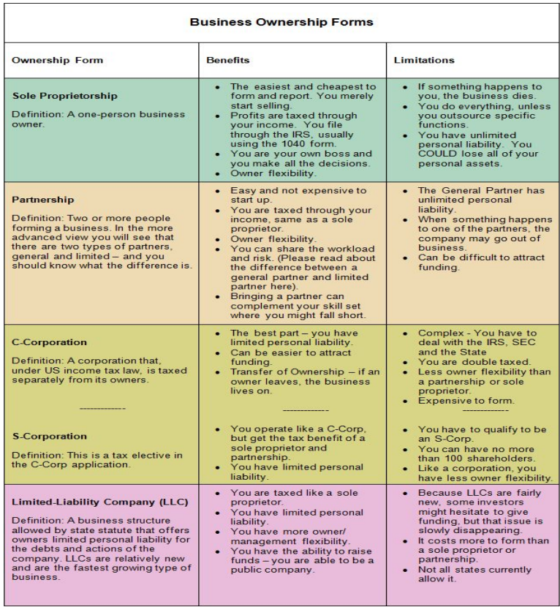

**5. Limited Liability Partnership (LLP)**

● An LLP is a legal entity available in some states to provide the simplicity and pass-through taxation of a partnership while limiting liability for the partners.

● In addition to a formal operating agreement among partners, LLPs generally require registration with the secretary of state.

● Where available, they are a popular type of business entity with professionals such as doctors, lawyers, accountants, architects, and engineers.

**Advantages of an LLP**

LLPs provide their owners with many advantages, including:

● **Limited liability:**

a. Like an LLC, an LLP is a separate legal entity with its own assets and obligations.

b. This protects partners from personal liability for legal and financial claims against the firm, although the degree of protection varies by state.

c. Generally, the partners’ liability is limited to their investments in the firm.

d. Partners may still be liable for their own personal errors and misconduct, so liability insurance is generally still required.

● **Ownership and control:**

Like partnerships, LLPs allow owners to actively participate in the business and control how it is run.

● **Tax options:**

LLPs may be considered pass-through entities, which can be advantageous for owners, particularly with the 20% QBI deduction. Their tax treatment varies by state, however.

**Disadvantages of an LLP**

Some limitations of LLPs include:

● **Limited availability:**

a. LLPs are not available in every state, and they may only be available to certain types of businesses.

● **Increased complexity:**

a. Because LLPs are treated differently in different states, partners will need to research their state requirements and tax laws thoroughly before choosing this structure.

**6. Limited Liability Company (LLC)**

● An LLC is a legal entity formed by creating an LLC operating agreement and filing articles of organization with the secretary of state.

● LLCs allow business owners to retain some of the advantages of sole proprietorship

○ while limiting legal and financial liability,

○ making them a popular business ownership structure for small businesses.

**Advantages of an LLC**

Limited liability is one of several benefits provided by an LLC:

● **Limited liability:**

a. When you form an LLC, you create a separate legal entity with its own assets and obligations.

b. Any legal claims against the business remain against the business, not its owners.

c. Members of an LLC may still be liable for their personal conduct, however, so liability insurance is generally advised.

**● Active ownership:**

a. LLCs allow ownership by two or more members who can exert as much control and involvement in the business as they like.

● **Tax options:**

a. LLCs are pass-through entities, which can be advantageous for owners, particularly with the 20% QBI deduction.

b. But LLCs also provide additional flexibility by allowing members to choose to be taxed as a corporation instead (see “corporations,” below).

c. This is generally advantageous to larger firms, but it gives LLCs flexibility as the business grows.

**Disadvantages of an LLC**

Following are some of the limitations of LLCs:

**● Complexity:**

a. LLCs must be formed by filing articles of formation with the state.

b. You also have ongoing regulatory paperwork to attend to, including maintaining a registered agent to receive legal documents and filing periodic reports where required with the state.

c. All of this adds up to extra administrative time and complexity.

**● Administrative costs:**

a. An LLC costs more to create and maintain than a sole proprietorship.

b. State filings generally require fees, and you may need software or support to complete them.

c. You may need extra legal and financial guidance to ensure that you’re getting the most out of your choices as well, which can further add to the costs.

**7. Series LLC**

● Currently available in 18 states and counting, series LLCs are an up-and-coming type of business ownership structure.

● Basically, they allow one parent LLC to form multiple internal LLCs in subsidiary fashion.

● These nested LLCs can be used to isolate liability for different business units. ●Series LLCs are complex, but worth discussing with your advisors if your business has distinct units that might benefit from individual treatment.

**Advantages of a series LLC**

Series LLCs provide numerous benefits, including:

● **Really limited liability:**

Each LLC within a series has separate members, assets, and liabilities.

● **Active ownership:**

Series LLCs allow owners to actively participate in the operation of their individual LLCs.

● **Tax options:**

Series LLCs retain the tax advantages and flexibility of traditional LLCs.

● **Unified filing:**

Despite the multiple LLCs, a series LLC is required to register and file taxes just once through the parent LLC.

The registrations and returns must encompass all LLCs, however, so they are still more complicated than a single LLC.

**Disadvantages of a series LLC**

Series LLCs have the following limitations:

**● Complexity:**

a. Despite the unified filing setup, it’s considerably more complex to manage multiple LLCs with separate assets and owners than a single entity.

b. Taxes in particular are complicated by the series structure.

**● Administrative costs:**

a. The added administrative burden means additional cost and guidance from professional advisors.

b. In addition, fees may be higher for forming a series LLC.

**8. C Corporation**

● A corporation is owned by shareholders who may have varying levels of control and involvement in the everyday operations of the business.

● In the case of stock corporations, ownership is issued in shares of stock.

● A corporation is formed by filing articles of incorporation with the state.

● The process of incorporation includes appointing a board of directors to oversee the business and establishing bylaws for its governance.

● With governance managed through a board of directors and ownership distributed among shareholders, corporations represent a further degree of separation between the business entity and its owners.

● Unlike sole proprietorships, partnerships, and LLCs, C corporations are not pass-through entities.

● Profits belong to the corporation and are subject to corporate income tax. They may also be distributed through dividends to shareholders.

**Advantages of a C corporation**

Some of the advantages include the following:

● **Limited liability:**

a. Like an LLC, a corporation is a separate legal entity with assets and liabilities of its own.

b. The liability of its shareholders is generally limited to the amount they have invested in the business.

**● Self-employment taxes:**

a. Shareholders who work in the business are paid and taxed as employees, sparing them from self-employment tax.

b. Income can be kept in the business as equity and distributed through shares and dividends, providing greater financial flexibility.

**● Access to capital:**

a. C Corporations can access capital by issuing stock.

b. They can make unlimited stock offers to individuals or businesses, including foreign or domestic investors. They can also issue multiple types of stock.

**Disadvantages of a C corporation**

Incorporation also has the following drawbacks:

**● Regulatory oversight:**

Corporations are subject to greater scrutiny than LLCs, being required to disclose earnings, governing documents, and other information annually to shareholders and in some cases the public.

**● Corporate tax:**

a. The profits of C corporations are subject to corporate tax.

b. Shareholders who work in the business and take a salary, as well as shareholders who earn dividends, also pay personal income tax on their earnings.

c. This results in two layers of taxation on the business’s profits.

● **Complexity and costs:**

Corporations are more complex and costly to form and maintain than other business entities.

**● Less control:**

Because ownership is spread among shareholders, and governance among a board of directors, corporations make it harder to exert individual control over the business.

**9. S Corporation**

● Some corporations can enjoy the benefits of pass-through taxation by electing to be taxed as an S corporation.

● To qualify, the corporation may not have more than 100 shareholders and may issue only one class of stock.

● Only individuals, certain estates and trusts, and certain tax-exempt organizations may own shares in an S corporation.

● An S corporation is formed through the same steps as a C corporation, with an additional election made through a filing with the Internal Revenue Service.

**Advantages of an S corporation**

The advantages of an S corporation include:

**● Limited liability:**

Like all corporations, S corporations limit the owners’ personal liability for the business’s debts and legal obligations.

**● Access to funding:**

S corporations can attract investment capital and other funding.

**● Pass-through taxation:**

S corporations qualify for pass-through taxation, which can reduce the tax burden for individual shareholders as well as for the business.

**Disadvantages of an S corporation**

Some of the drawbacks of S corporations include the following:

**● Higher startup costs:**

Like any corporation, S corporations cost more to start and operate than LLCs and sole proprietorships.

**● Increased complexity:**

S corporations must regularly report earnings and other information to shareholders.

**● Limits on ownership:**

S corporations may be owned only by individuals who are U.S. citizens or residents, and they can issue only one type of stock.

**10. Nonprofit Corporation**

● Most nonprofits are formed as corporations that apply for tax-exempt status under Section 501(c) of the IRC.

● Their entity formation process is the same as that of other corporations, with articles of incorporation filed with the secretary of state, a board of directors, and bylaws for governance.

● Nonprofits may be formed solely for the tax-exempt purposes specified in Section 501(c), however, and they are subject to specific regulatory requirements in each state.

● Contrary to popular belief, nonprofits can and should generate profits.

● The difference between a nonprofit entity and a for-profit entity is how those profits are invested.

● Rather than being distributed to shareholders, profits are reinvested in the nonprofit’s operations to serve its charitable mission.

**Advantages of a nonprofit corporation**

● **Liability protection:**

Nonprofit corporations provide the same limits on liability as other corporations, protecting you from personal liability for the nonprofit’s operations.

**● Tax exemption:**

Nonprofits may qualify for exemption from federal taxes as well as many state and local taxes. This allows nonprofits to stretch their budgets and apply maximum resources toward their missions. Federal tax exemption is not a blanket exemption from all taxes, however. Nonprofits that achieve federal tax-exempt status generally need to apply separately for exemption from state and local taxes such as sales tax.

**Disadvantages of a nonprofit corporation**

**● Limited activities:**

Nonprofits must limit their activities to the pursuit of charitable purposes.

**● Limited access to funding:**

Nonprofit organizations rely on grants and charitable contributions to fund their operations.

**● Increased regulatory oversight:**

In addition to the usual duties of corporations, nonprofits have unique registration and reporting requirements to manage at the state and federal levels.

**11. Benefit corporation**

● Benefit corporations are corporations formed to serve a public benefit in addition to the usual corporate mission of earning profits.

● They are structured like other corporations with a board of directors and bylaws, yet the board is responsible for measuring and reporting on its social impact as well its financial performance. Benefit corporations are an increasingly popular structure for entrepreneurs who want to do good while doing business.

**Advantages of a benefit corporation:**

**● Limited liability:**

Like any other corporation, a benefit corporation limits its shareholders’ liability for financial and legal claims.

**● Access to funding:**

Benefit corporations can take advantage of investor capital and revenue from commercial activities to accomplish their social missions.

**● Profit distribution:**

Like other corporations, benefit corporations can distribute profits to shareholders as dividends.

**Disadvantages of a benefit corporation**

**● Varying regulations:**

Benefit corporations are currently available in 35 states. This map from B Lab shows where they are available. Each state has its own rules for what types of social benefits qualify and how they must be measured and reported, which means additional complexity in forming and running the business.

**● Increased regulatory oversight:**

Benefit corporations must meet all of the usual regulatory requirements of corporations plus report on their social and financial impact annually to shareholders.

**● Corporate tax:**

Benefit corporations are subject to federal corporate income tax.

**12. Low-Profit Limited Liability Company (L3C)**

● L3C is a relatively rare business type that combines the legal structure of an LLC with the charitable mission of a nonprofit.

● An L3C can distribute modest profits to its members, yet this must always be secondary to the primary purpose of furthering a charitable mission. L3Cs may not be formed for political or legislative purposes.

● L3Cs were conceived as an investment vehicle for foundations, which must give 5% of their assets to a charitable program or program-related investment (PRI) each year.

● That plan ran into some hurdles with the IRS, however, and the L3C structure has not been widely adopted as a result.

**Advantages of an L3C An L3C offers some advantages:**

**● Liability protection:**

L3Cs provide the same limits on liability as LLCs, protecting you from personal liability for the business’s operations.

● **Flexible ownership:**

Members of an L3C can maintain ownership and control and actively participate in the day-to-day operations of the business.

**● Pass-through taxation:**

L3Cs qualify for pass-through taxation.

**Disadvantages of an L3C:**

**● Lack of tax exemption:**

L3Cs do not qualify for federal tax-exempt status, and are therefore less attractive than incorporation for social enterprises.

**● Regulatory uncertainty:**

Because the IRS has not officially sanctioned L3Cs as PRIs for foundations, their usefulness and longevity are uncertain. They are currently permitted in only nine states.

**Module - 3-Venture planning**

Q1)What are the Pathways to New Ventures for Entrepreneurs and Approaches for Creating a New Venture ?

The pathways to new Ventures are :-

* Acquiring an Existing Venture
* Creating a new venture
* Obtaining a Franchise

The Approach for creating a New Venture can be:-

* New New Approach
* New Old Approach

Q2 ) Key factors to consider when Acquiring an Existing Entrepreneurial Venture?

**Personal Preferences**

**Examination of Opportunities**

**Asking Key Questions**

1. Why is this business being sold ?
2. What is the current physical condition of the business?
3. What is the state of other assets of the business?
4. What type of competition does the business face?
5. What does the Financial Picture of business look like?

**Evaluation Of the Venture**

1. The Business environment
2. Profits, sales and operating ratio
3. Assets of the venture

**Advantages of Acquiring an Ongoing Venture**

* Less fear for the successful future Operation
* Reduced Time and Effort
* Purchasing at a Good Price
* Access to the business Customer Base

**Disadvantages of Acquiring an Ongoing Venture**

* You’ll get what you paid for
* You could get Scammed
* The Business might have a Bad Reputation
* Significant Operational Changes may be needed

**Factors Affecting the Negotiation**

* Information
* Pressure
* Alternatives
* Time

Q3) What is Franchising and How does it work?

**Franchising**

* Any arrangement in which the owner of a trademark, trade name, or copyright has licensed others to use it in selling goods or services.

**Franchisee**

* A purchaser of a franchise

**Franchisor**

* The seller of the franchise

**Franchisee Obligations:**

* Make a financial investment in the operation.
* Obtain and maintain a standardized inventory and/or equipment package usually purchased from the franchisor.
* Maintain a specified quality of performance.
* Follow a franchise fee as well as a percentage of the gross revenues.
* Engage in a continuing business relationship.

**Franchisor Provides:**

* The company name that provides drawing power.
* Identifying symbols, logos, designs, and facilities.
* Professional management training for each independent unit’s staff.
* Sale of merchandise necessary for the unit’s operation, equipment to run the operation, and the food or materials needed for the final product.
* Financial assistance, if needed.
* Continuing aid and guidance to ensure that everything is done in accordance with the contract.

**Advantages**

* Training and guidance
* Brand-name appeal
* A proven track record
* Financial assistance

**Disadvantages**

* Franchise fees
* Franchisor control
* Unfulfilled promises of franchisor

**The cost of Franchising**

1. The basic franchising fee
2. Insurance
3. Opening product inventory
4. Remodeling and leasehold improvements.
5. Utility charges
6. Payroll
7. Debt service
8. Bookkeeping and accounting fees
9. Legal and professional fees
10. State and local licenses, permits, and certificates

**Franchise Disclosure Document (FDD)**

* Is divided into 24 items that provide different segments of information for prospective franchisees.
* Was developed to provide guidance in complying with the Franchise Disclosure Rule that requires franchisors to make full presale disclosure about their franchises.

Q4) What are the elements of a Business Plan ?

* Executive Summary
* Product or Service
* Management team
* Market and Competition
* Marketing and Sales
* Business system and organization
* Implementation schedule
* Opportunities and risks
* Financial Planning and financing

You can ask key questions in each of the elements while doing thorough analysis for that please refer to slides(pg 34-44)

Q5) Competition Analysis (VVIMP)

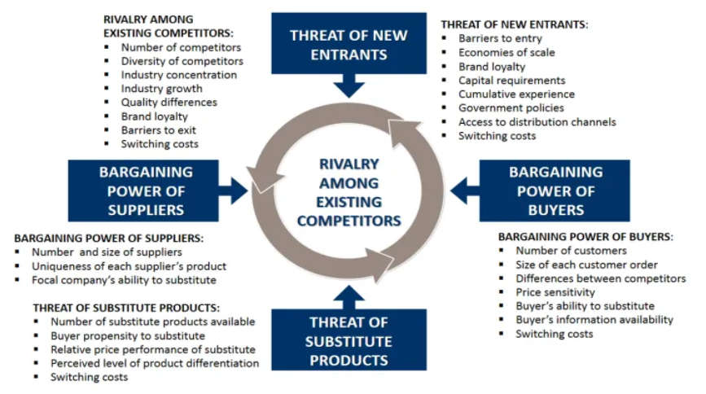

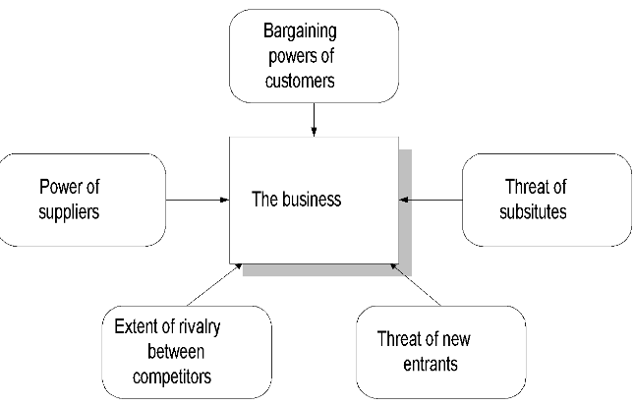

Q6) Marketing Analysis (again VVIMP)

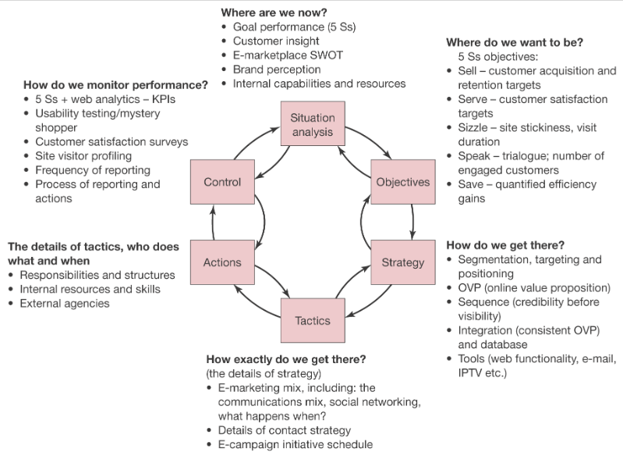

Q7 ) Situation Analysis

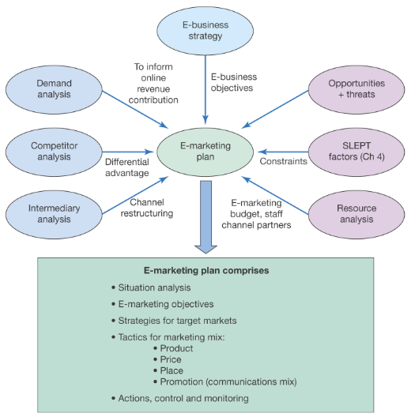

Q8) Real life application of Venture Planning

**Module 4: Financing and Managing venture**

* Financing Stages
* Sources of Finance
* Venture Capital
* Criteria for evaluating new-venture proposals & Capital-process.
* Management of venture: objectives and functions of management
* scientific management
* general and strategic management
* introduction to human resource management: planning, job analysis, training, recruitment and selection

**Q) Stages of VC Funding.**

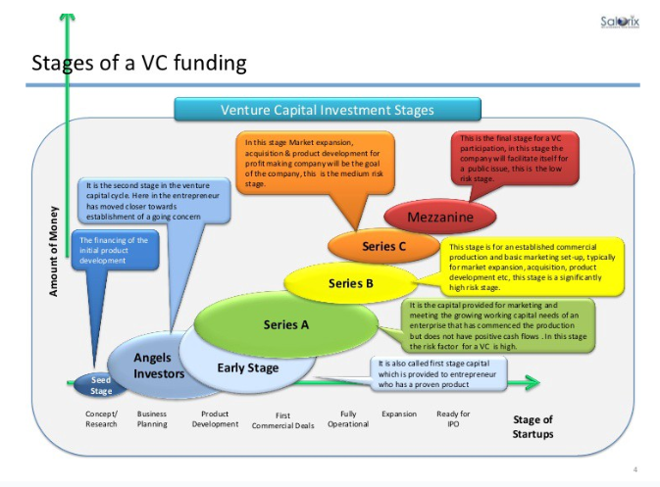

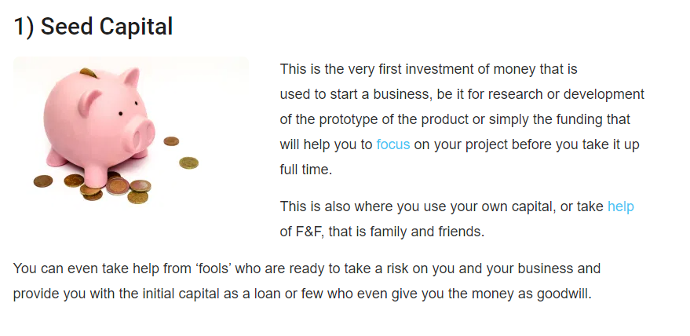



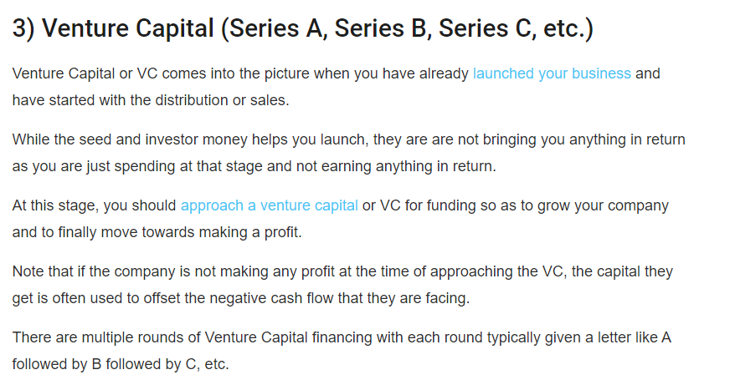

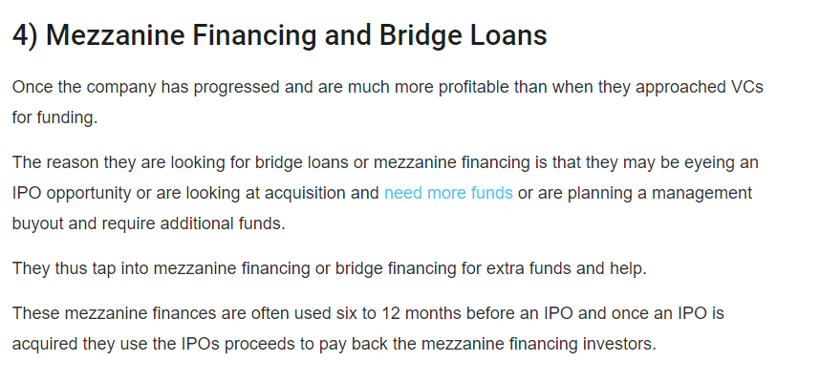

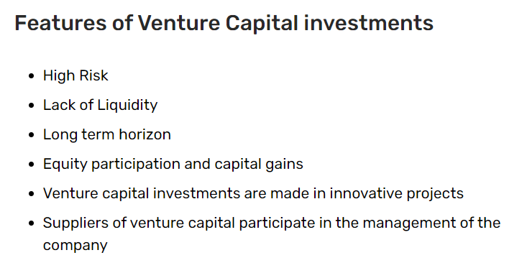

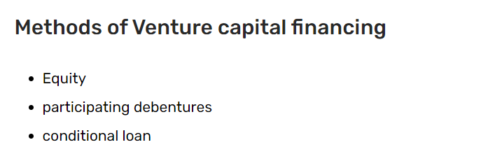

**Q) Acquiring a funding from VC**

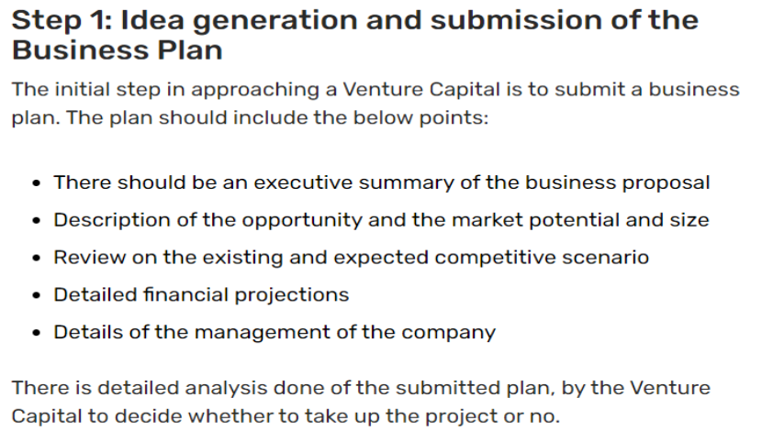

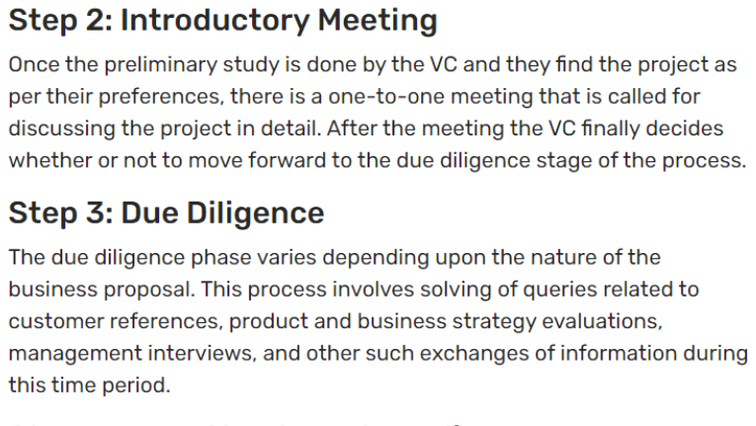

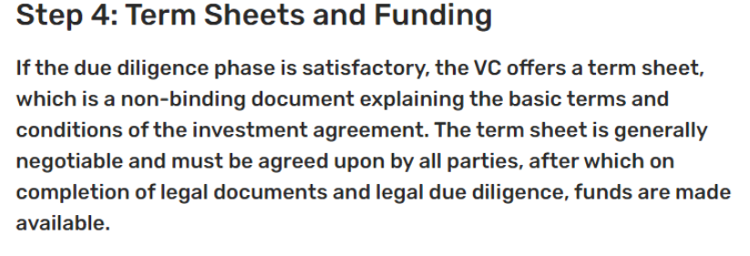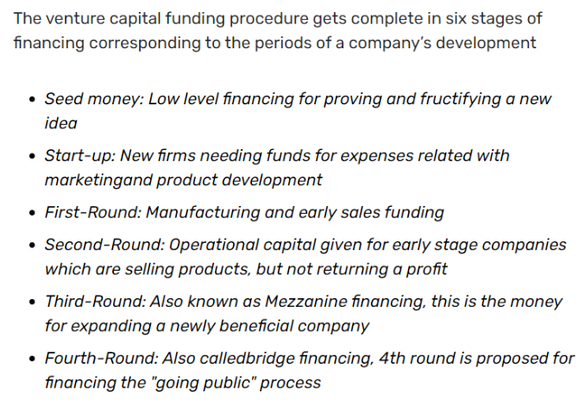

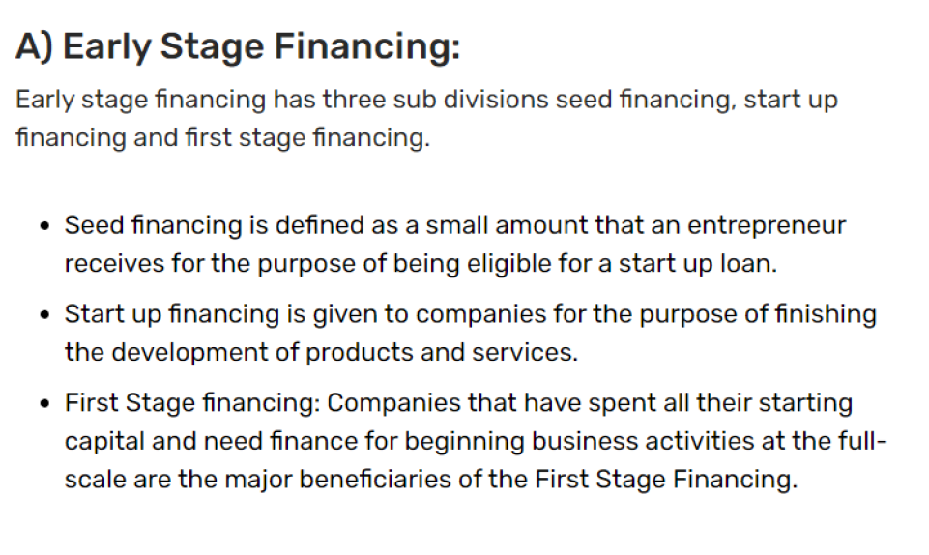

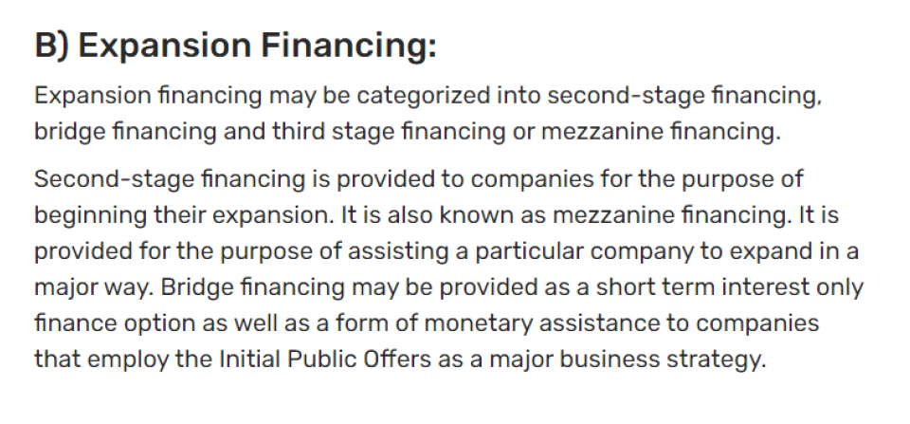

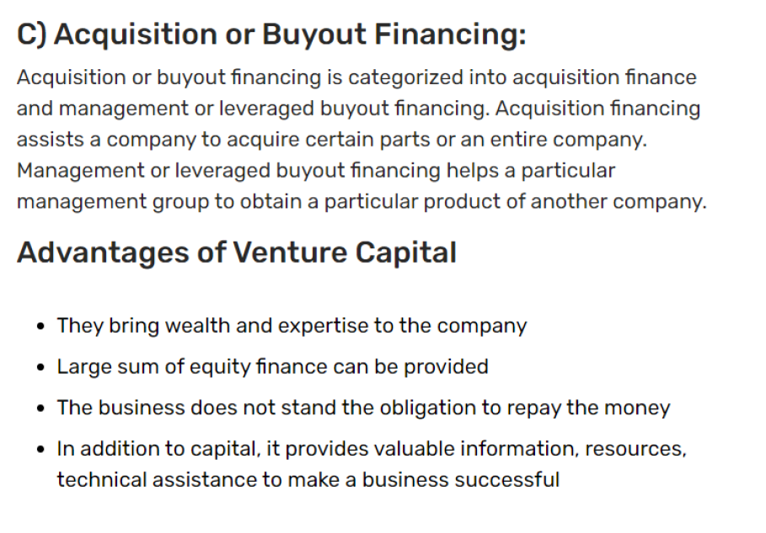

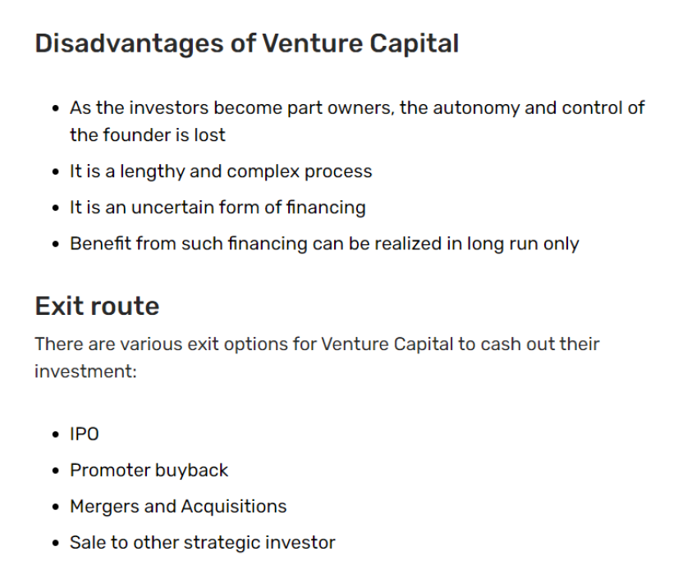

**Q) Sources of Finance- Debt vs Equity Financing**

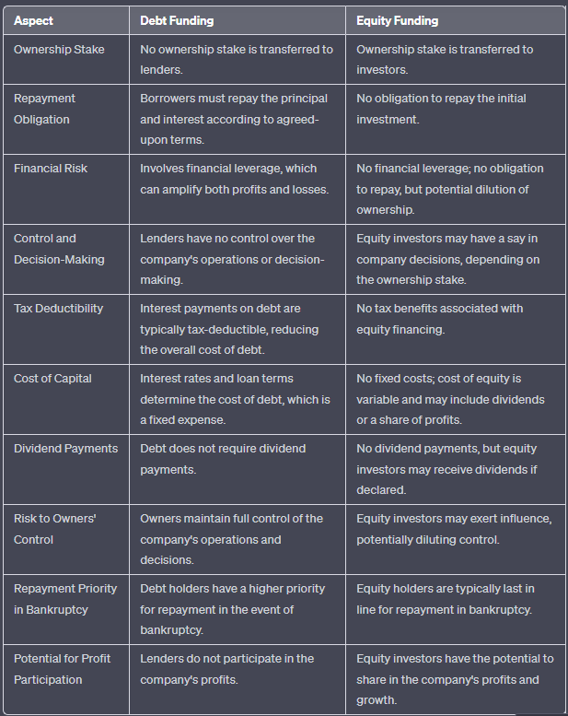

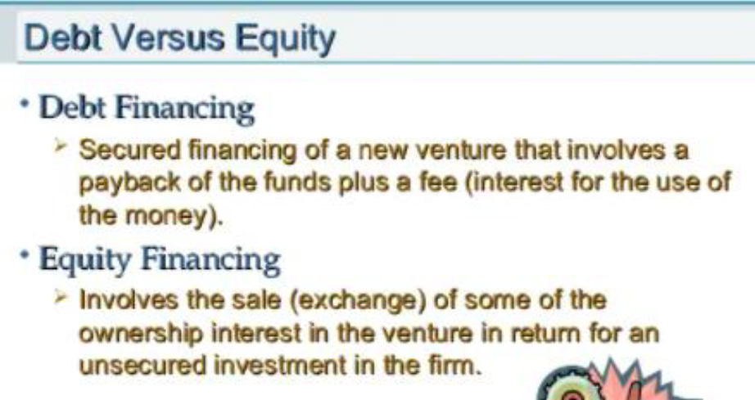

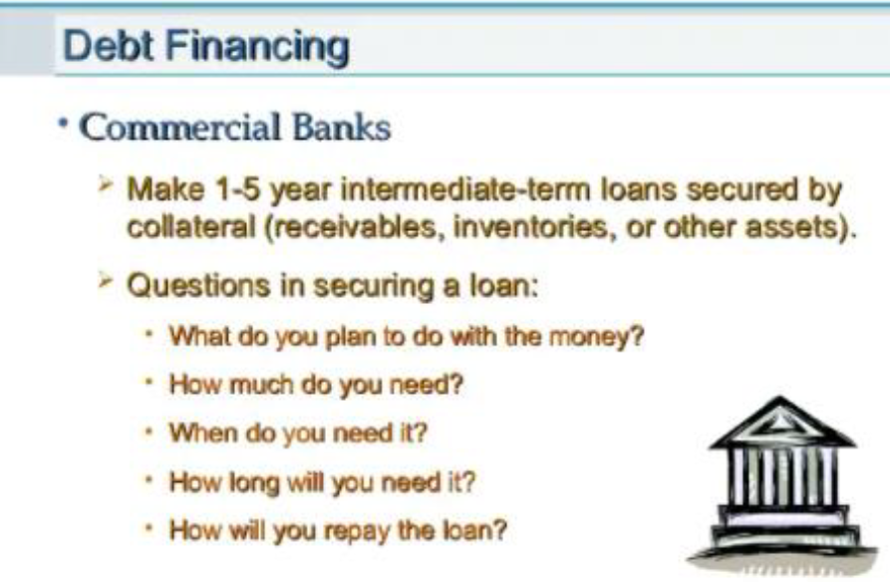

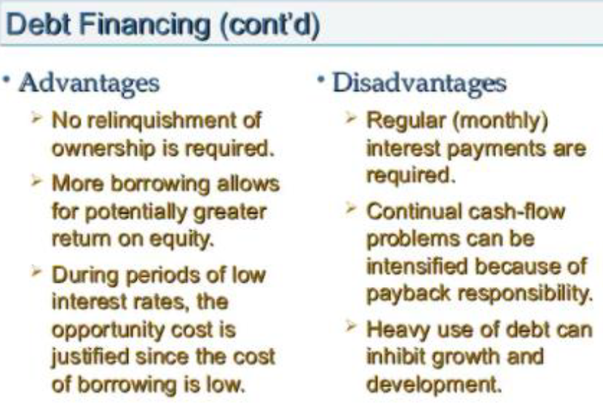

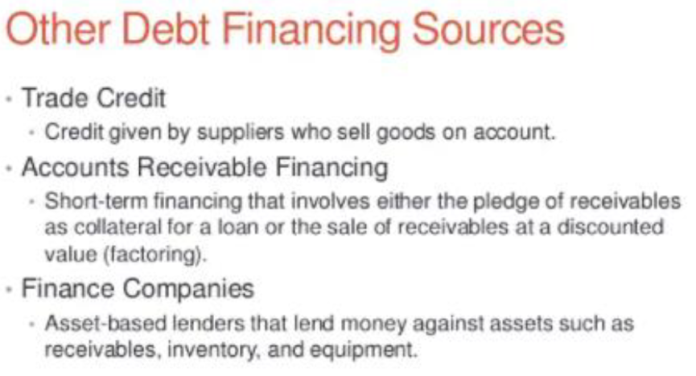

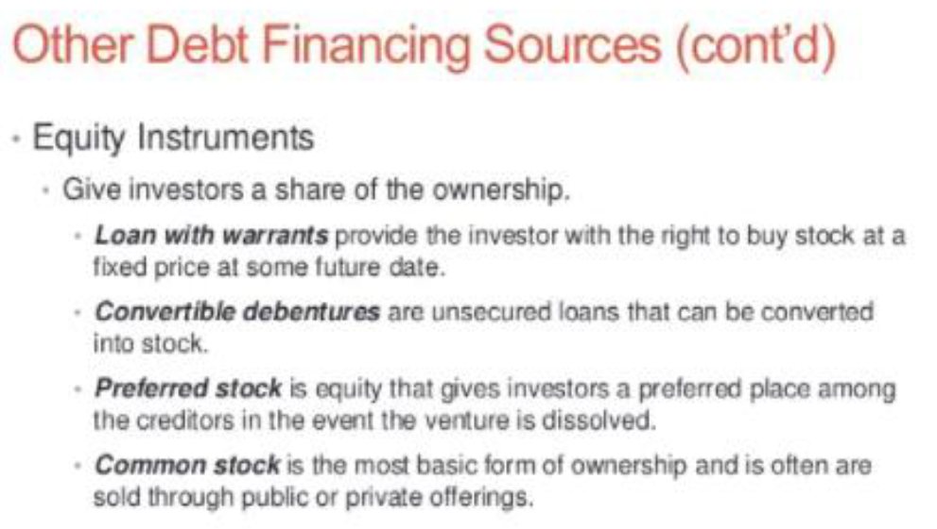

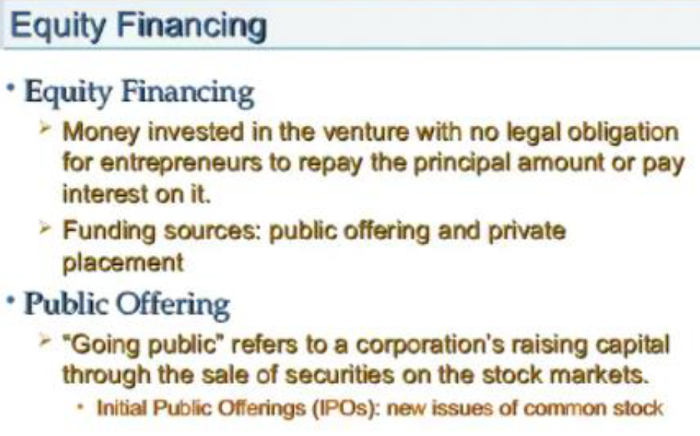

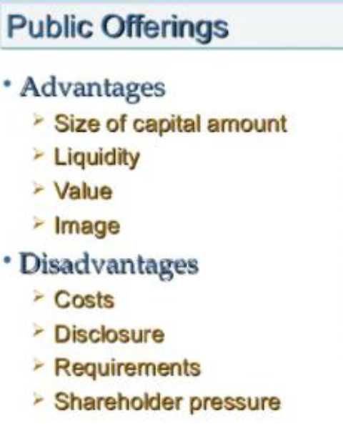

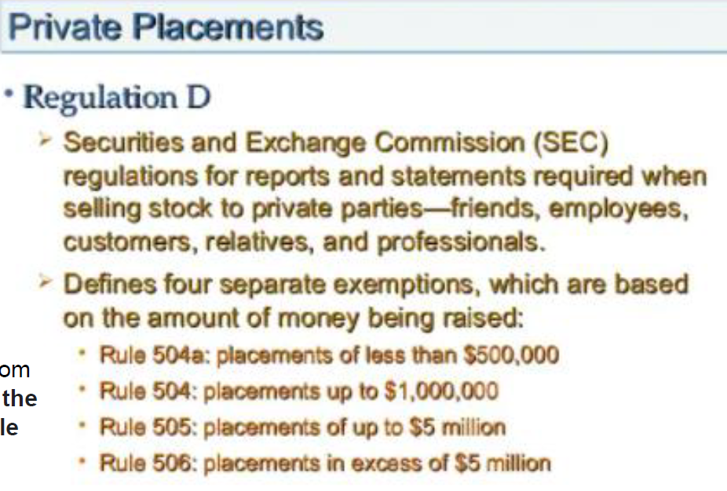

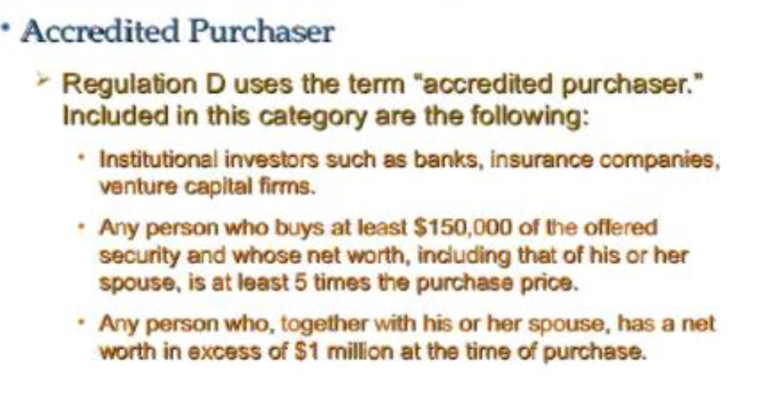

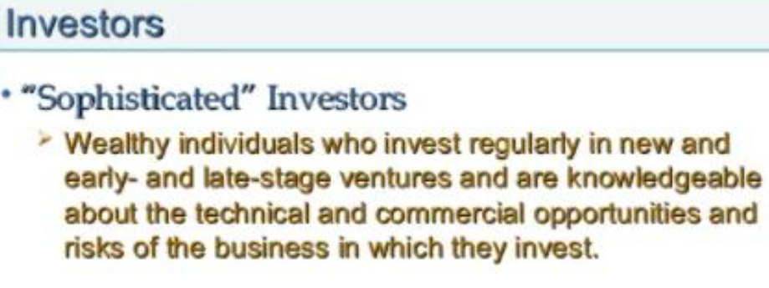

**Q) Venture Capital**

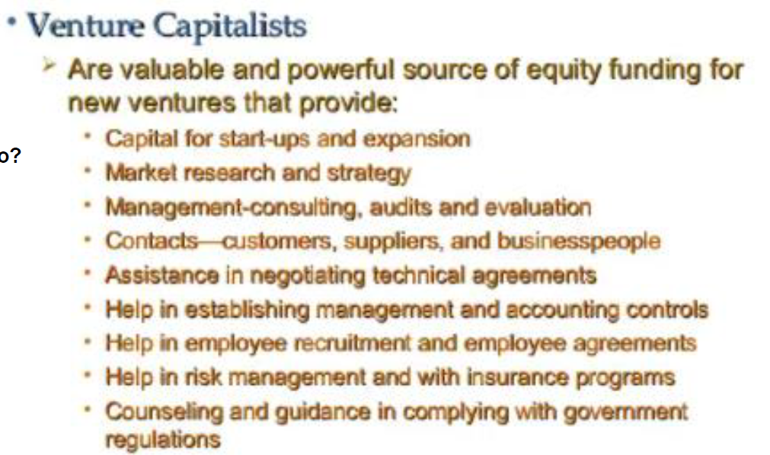

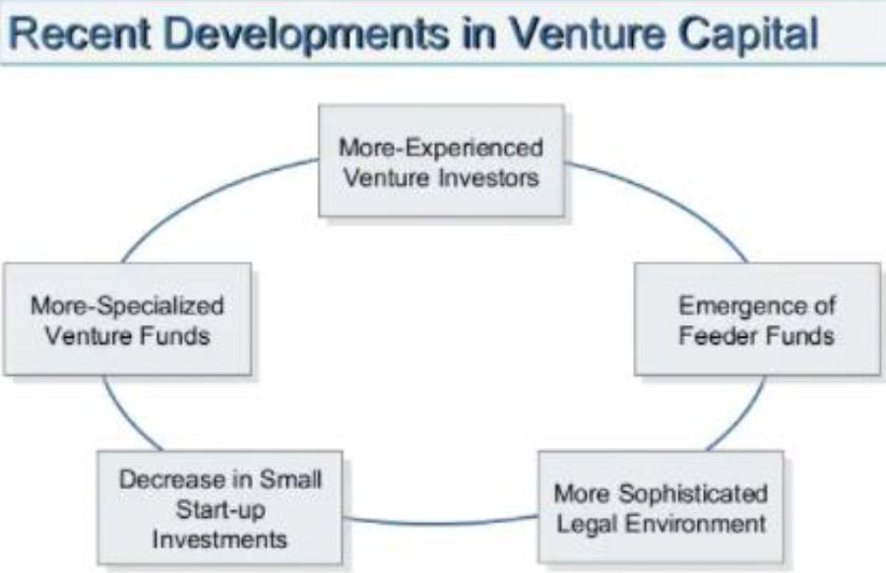

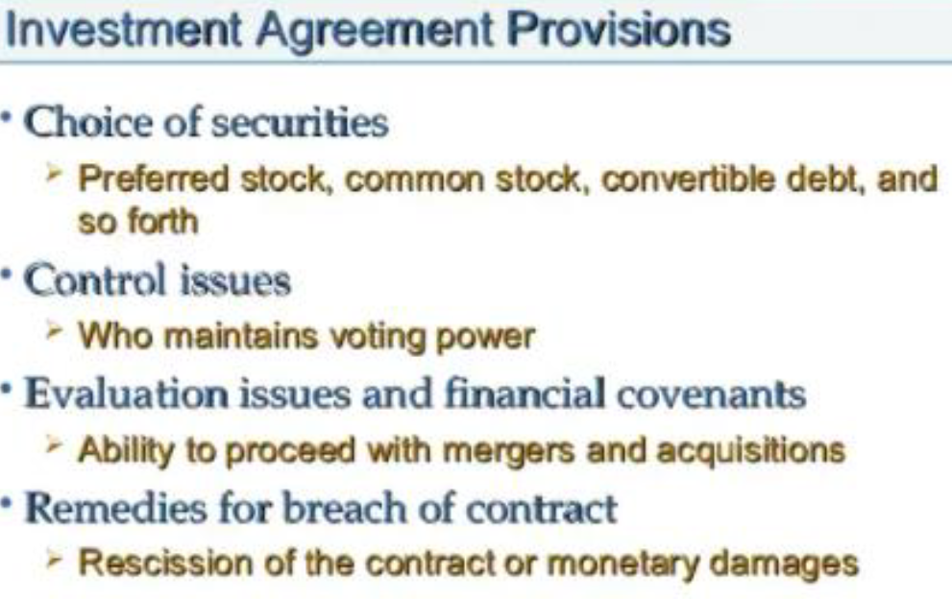

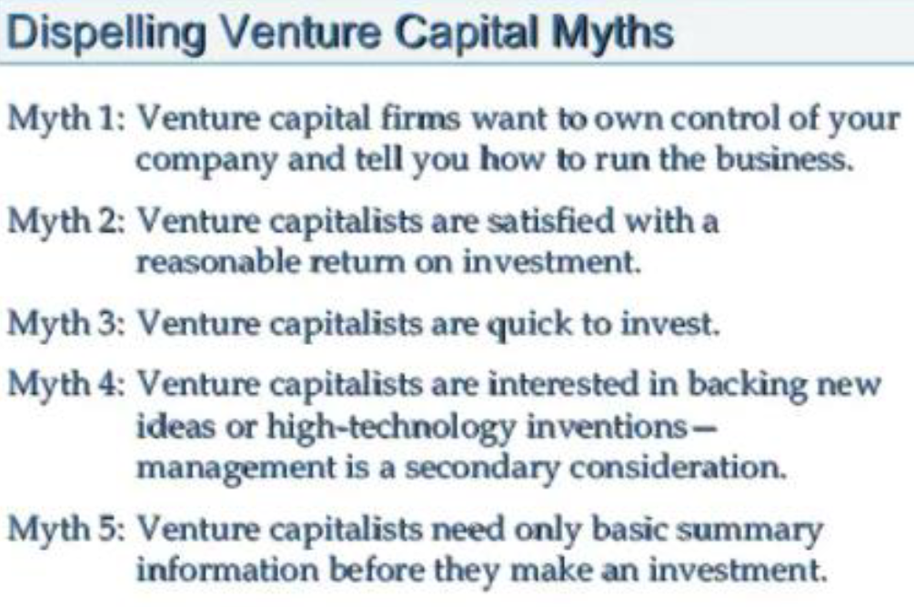

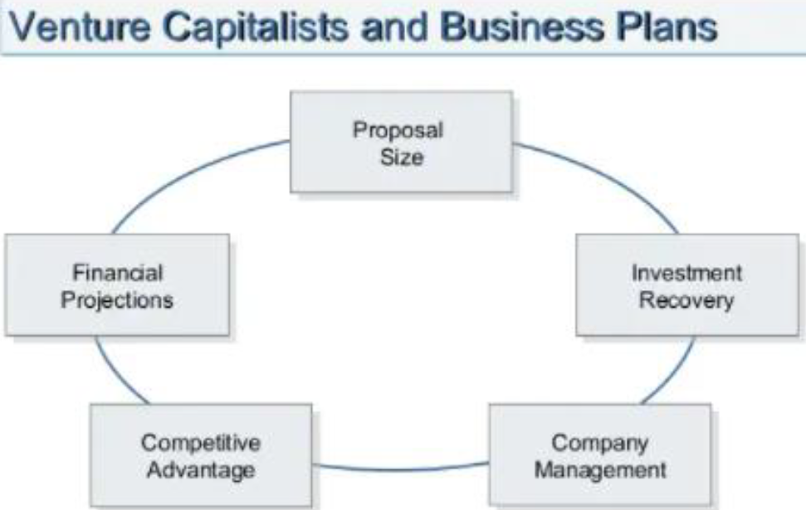

**Q) Criteria for evaluating new-venture proposals & Capital-process.**

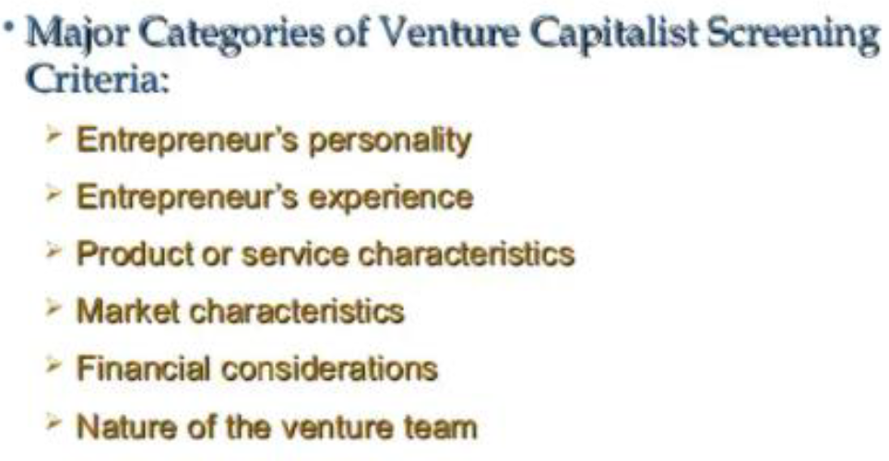

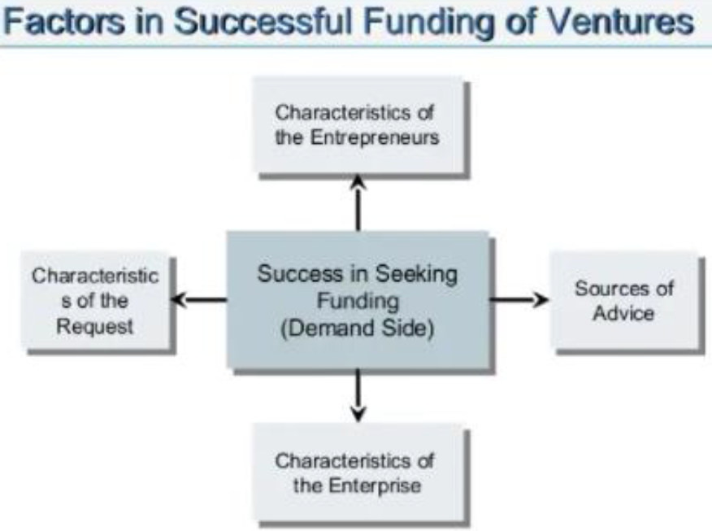

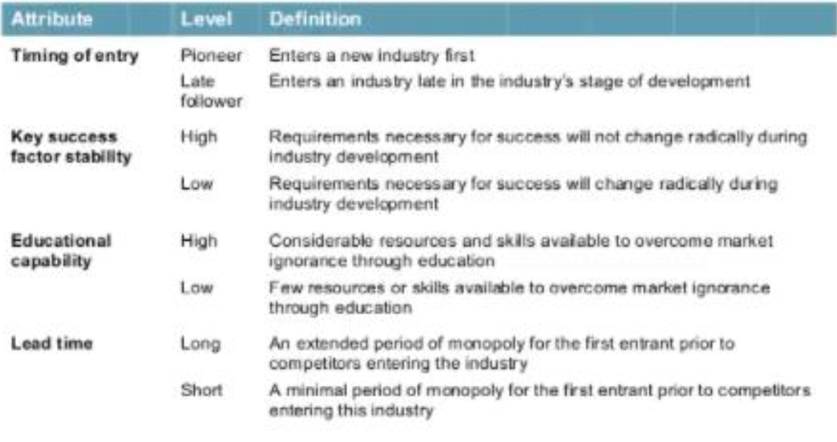

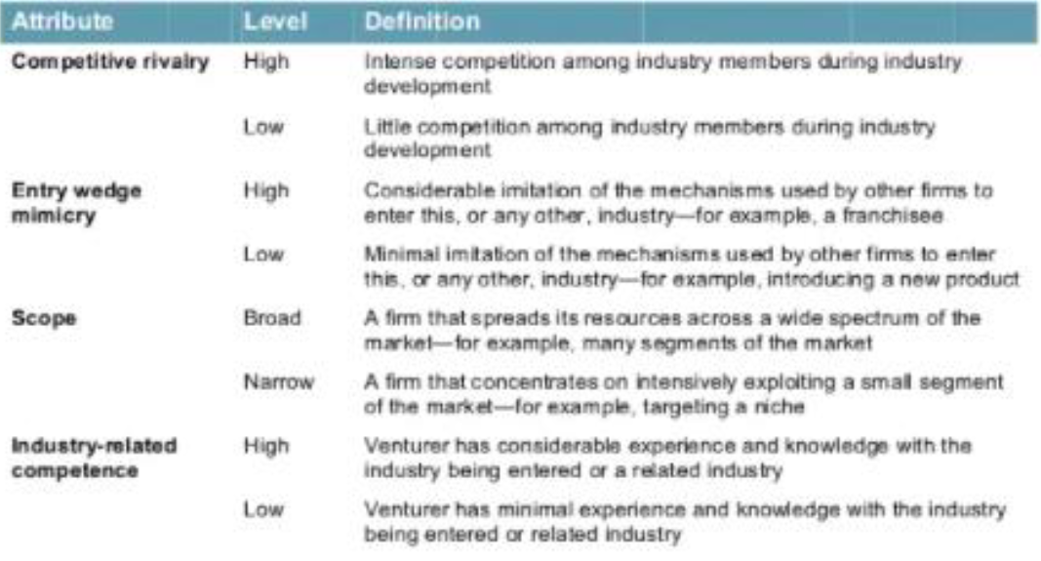

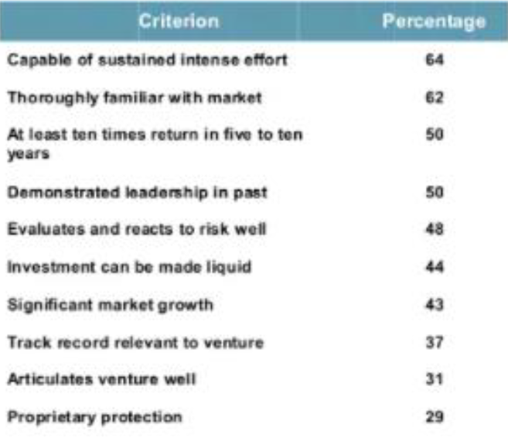

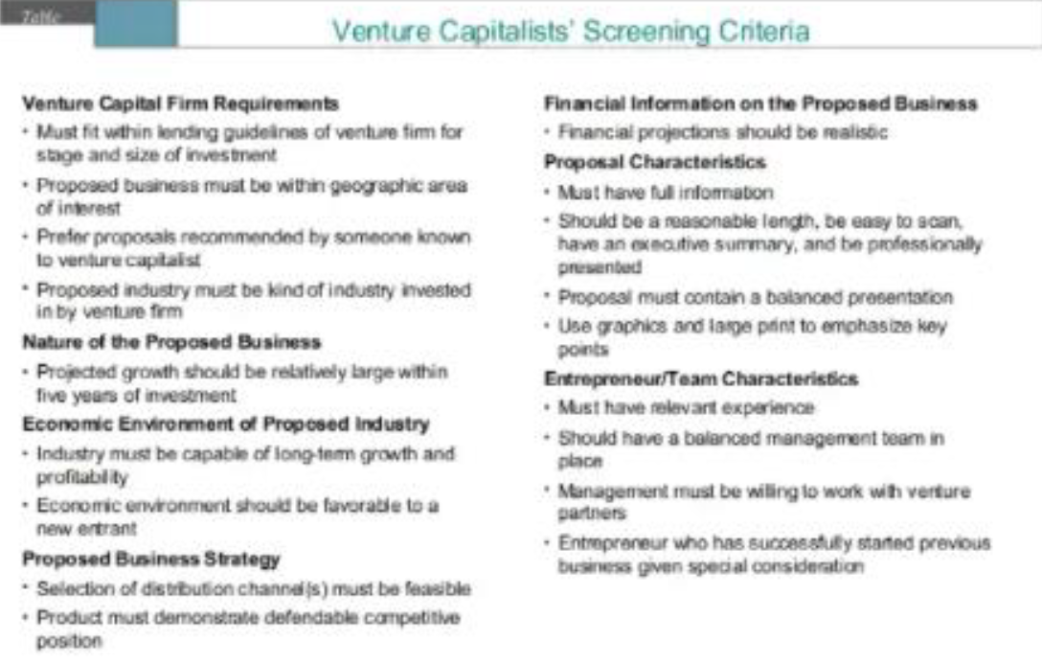

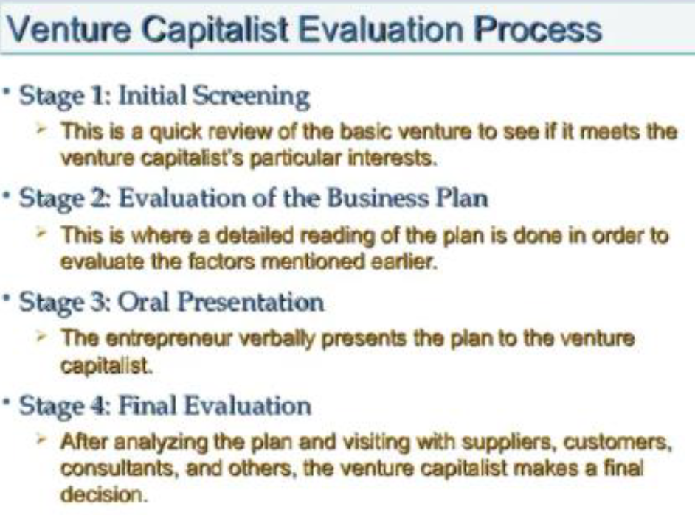

Ye ma’am ne achanak bich mein ye dala tha ppt mein so adding here as well ;)

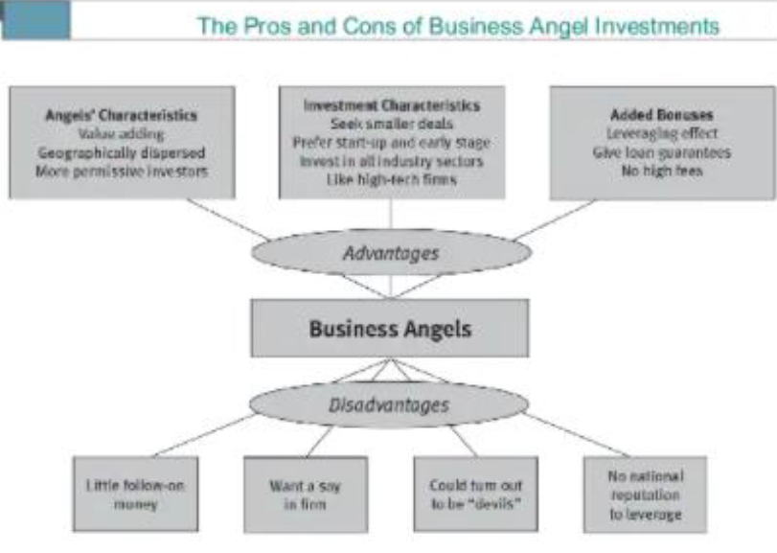

(Points in red not available in Shanta mam ppt added from D15B PPT)

Management of

venture: objectives and functions of management, scientific management,

**Management of ventures…**

**4.1)what is it**

a)venture management is a business management discipline that focuses on being both innovative and challenging in the realm of introducing what could be a completely new product or entering a promising newly emerging market.

b)The discipline is focused on the skills, practices and technology required to manage the rapid growth of new business in highly dynamic environments.

c) These environments are often characterized by rapid technology change

**4.2) Objectives….**

The basic motive behind any venture management   
a)program is to look beyond the existing business uncertainty in a particular market.

b)This is typically done by experimenting with new ideas and business actions.

c)The primary aim is then to enhance entrepreneurial activity by exploiting new areas of growth.

**4.3) functions of management of ventures**

**a)Planning**

a.1)It deals with chalking out a future course of action & deciding in advance the most appropriate course of actions for achievement of pre-determined goals.

a.2)Planning is deciding in advance what to do, when to do & how to do it.

a.3)It bridges the gap from where we are & where we want to be. A plan is a future course of actions.

a.4)It is an exercise in problem solving & decision making.

a.5)Planning is determination of courses of action to achieve desired goals. Thus, planning is a systematic thinking about ways & means for accomplishment of pre-determined goals. Planning is necessary to ensure proper utilization of human & non-human resources. It is all pervasive, it is an intellectual activity and it also helps in avoiding confusion, uncertainties, risks, wastages etc.

**4.3) functions of management of ventures**

**bOrganizing**

b.1)It is the process of bringing together physical, financial and human resources and developing productive relationships amongst them for the achievement of organizational goals.

b.2) it with everything useful or its functioning

b.3) To organize a business involves determining & providing human and non-human resources to the organizational structure.

**4.3) functions of management of ventures**

**c) Staffing**

c.1)It is the function of manning the organization structure and keeping it manned.

c.2)Staffing has assumed greater importance in recent years due to advancement of technology, increase in size of business, complexity of human behavior etc.

c.3)The main purpose of staffing is to put right man on right job . proper and effective selection, appraisal & development of personnel to fill the roles designed

**4.3) functions of management of ventures**

**d)Directing**

d.1)it actuates the organizational methods to work efficiently for achievement of organizational purpose.

d.2)Direction is that inert-personnel aspect of management which deals directly with influencing, guiding, supervising, motivating subordinate for the achievement of organization

**e) Controlling**

e.1)It implies measurement of accomplishment against the standards and correction of deviation if any to ensure achievement of organizational goals.

e.2) The purpose of controlling is to ensure that everything occurs in conformities with the standards.

e.3)An efficient system of control helps to predict deviations before they actually occur

**4.4) Scientific management:**

It is a management theory that analyzes work flows to improve economic efficiency.

general and strategic management;

**4.5) Strategic management**

Clarify your vision. Setting well-defined goals should clarify your vision for your organization. ...

Collect and analyze information. This stage is important because the information you gain can have an impact on the next two steps.

Devise a strategy.

Execute your strategy.

Evaluate and control.

introduction to human resource management: planning, job analysis, training, recruitment and selection

**4.6) Human resource management (HRM)** is the practice of recruiting, hiring, deploying and managing an organization's employees.

Planning:-

planning of all activates, making the colander,

Job analysis:-

which jobs to offer, where, at what cost, budget

Training:-

.when to arrange, how to arrange, who will train

Recruitment:-

process definition and implementation

Selection:-

process of selection, documentation, all legal matters.

**Module 5: Overview of E-business**

Concept of E-business, Business Success through adoption of technology,

information management for business Initiatives,

Performance improvement through e-business. Introduction to various collaborative partnerships,

E-commerce: Sectors of ecommerce, B to C, B to B and C to C ecommerce,

Ecommerce success factors, clicks and Bricks in ecommerce, collaborative commerce. E-Marketplace,

M-commerce,

E-Government;

Various E-business Models, Challenges of the E-Business Models, Globalization of E-business.

**Q 1) What is Ecommerce and Ebusiness?**

**E-commerce :**

* All electronically mediated information exchange between an organization and its external stakeholders (Chaffey)
* Digitally enabled commercial transactions between and among organizations and individuals.

**E-business:**

* All electronically mediated information exchanges, both within an organization and with external stakeholders supporting the range of business process (Chaffey)
* Digital enablement of transactions and processes within a firm, involving information systems under firm’s control. Does not include commercial transactions involving an exchange of value across organizational boundaries (Laudon)

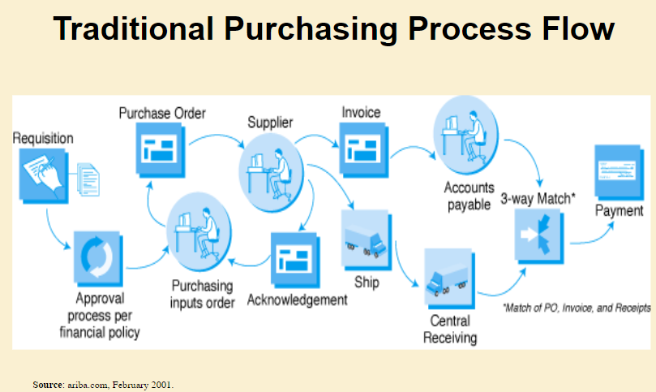

**Q2) E-business concepts**

E-business defined from the following perspectives:

1. Communications: delivery of goods, services, information, or payments over computer networks or any other electronic means
2. Commercial (trading): provides capability of buying and selling products, services, and information on the Internet and via other online services.
3. Business process: doing business electronically by completing business processes over electronic networks, thereby substituting information for physical business processes
4. Service: a tool that addresses the desire of governments, firms, consumers, and management to cut service costs while improving the quality of customer service and increasing the speed of service delivery
5. Learning: an enabler of online training and education in schools, universities, and other organizations, including businesses
6. Collaborative: the framework for inter- and intra-organizational collaboration
7. Community: provides a gathering place for community members to learn, transact, and collaborate

**Q 3) Buy side and Sell side**

Ma’am ka ppt

Buy-side e-commerce – refers to transactions to procure resources needed by an organization from its suppliers.

Sell-side e-commerce refers to transactions involved with selling products to an organization’s customers.

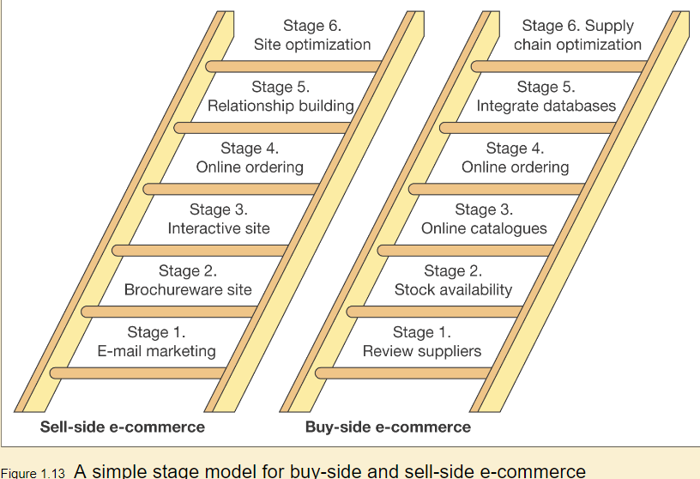

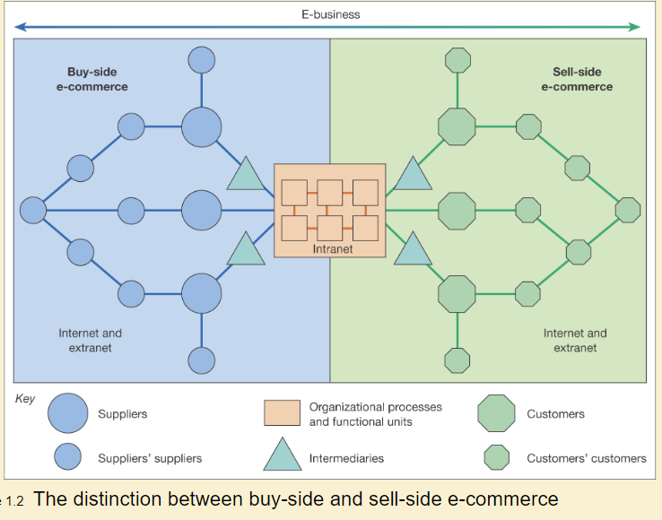

Ques10 ka ans hai 👇

**i. Buy side e-commerce:**

* Buy side e- commerce refers to transactions to procure resources needed by an organisation from its suppliers.
* They basically indicate using communications technology to support the upstream supply chain from procurement to inbound logistics.
* They are e-commerce transactions between a purchasing organization and it suppliers, possibly through intermediaries.
* Example: E-business application developed by Shell Chemicals is an excellent example for buy side e-commerce. Prior to the development of this application, there was a danger that Shell’s customers might run out of an essential chemical and eventually revenues would be lost. Hence, this application helped them to manage their customer’s inventory based on data shared by its customers about their usage and forecast demand for chemicals.

**Advantages of using this application include:**

1. Reduces the need for excess inventory storage.
2. Quick availability of product when required
3. Transaction costs like invoices and data entry is reduced.
4. Order processing overhead is reduced.

**ii.Sell side e-commerce:**

Sell side e-commerce refers to transactions involved with selling products to an organisations customer.

They doesn’t only involve selling products such as books and CD’s online, but also involves using internet technologies to market services using a range of techniques.

It is useful to consider the four main types of online presence for sell side e-commerce which are as follows:

1. Transactional e-commerce sites: These enable purchase of product online. The main business contribution of the site is through sale of these products.
2. Services-oriented relationship-building websites: Provide information to stimulate and build relationship. Products are not available for purchase online. Information is provided through website and e-newsletters to inform purchase decisions. The main business contribution is through encouraging offline sales and generating enquiries or leads from potential customers.
3. Brand-building sites: Provide an experience to support the brand. Products are not typically available for online purchase. Their main focus is to support the brand by developing an online experience of the brand.
4. Portal or Media sites: Provide information or news about a range of topics. Portal refers to gateway of information. This is information both on the site and through links to other sites.

Example: Example of sell side e-commerce include Retail sites (like Amazon), online banking services (like HSBC), Portals (like Yahoo) etc.

**Q 4) Why study E-commerce?**

E-commerce technology is different, more powerful than previous technologies

E-commerce bringing fundamental changes to commerce

Traditional commerce:

Passive consumer

Sales-force driven

Fixed prices

Information asymmetry

**Q5) Unique Features of E-commerce Technology**

1. Ubiquity
2. Global reach
3. Universal standards
4. Information richness
5. Interactivity
6. Information density
7. Personalization/customization
8. Social technology

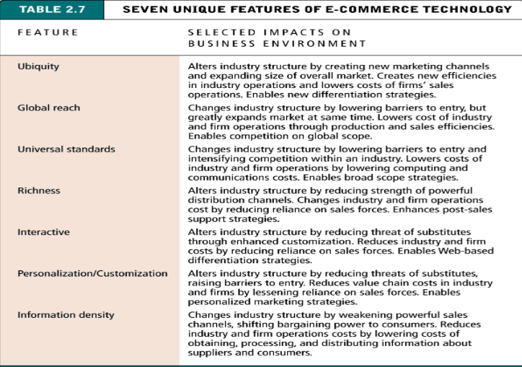

**Q6) Types of E-commerce models**

Classified by market relationship

1. Business-to-Consumer (B2C)
2. Business-to-Business (B2B)
3. Consumer-to-Consumer (C2C)

Classified by technology used

1. Peer-to-Peer (P2P), e.g., BitTorrent and Napster
2. Mobile commerce (M-commerce)

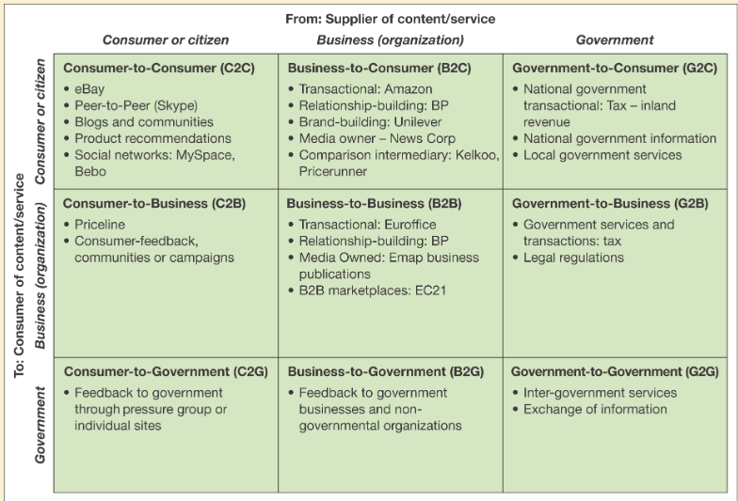

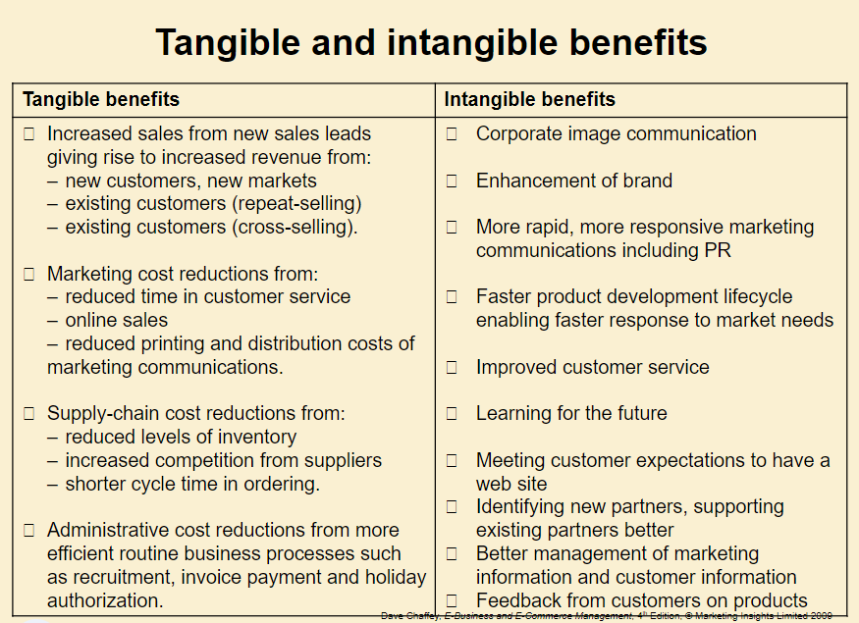

**Cost/efficiency and competitiveness drivers**

Cost/efficiency drivers

1. Increasing speed with which supplies can be obtained
2. Increasing speed with which goods can be dispatched
3. Reduced sales and purchasing costs
4. Reduced operating costs

Competitiveness drivers

1. Customer demand
2. Improving the range and quality of services offered
3. Avoid losing market share to businesses already using e-commerce

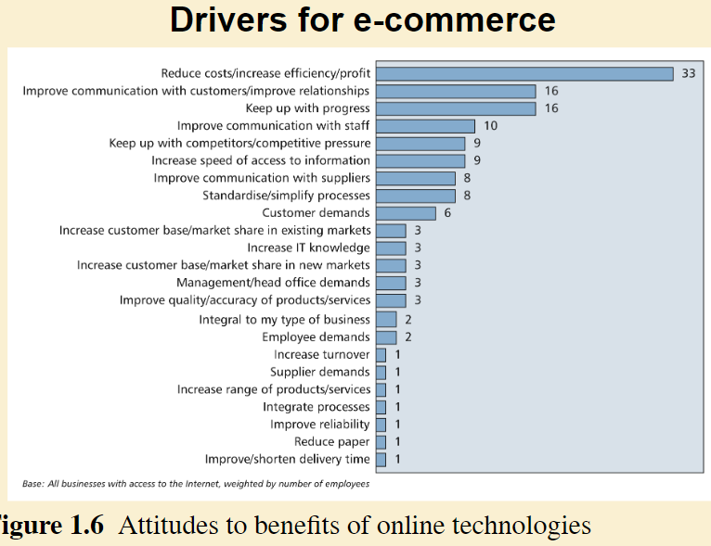

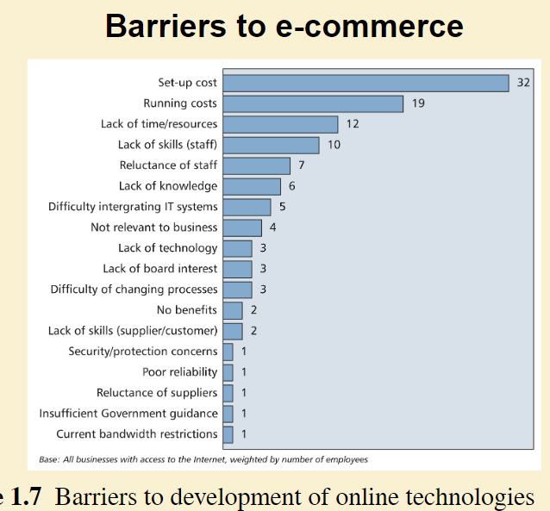

Potential Limitations on B2C E-commerce:

1. Expensive technology
2. Sophisticated skill set
3. Persistent cultural attraction of physical markets and traditional shopping experiences
4. Persistent global inequality limiting access to telephones and computers
5. Saturation and ceiling effects

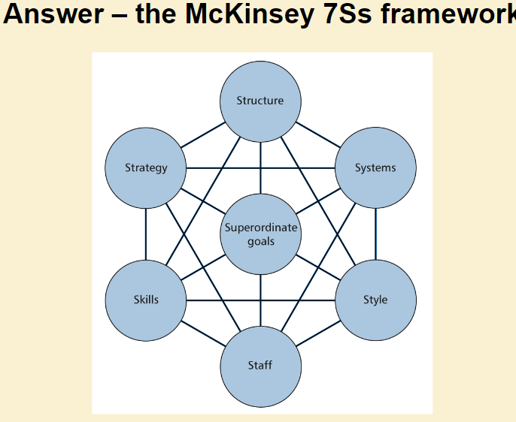

**Q 7) What is a business model?**

Timmers (1999) defines a ‘business model’ as:

An architecture for product, service and information flows, including a description of the various business actors and their roles; and a description of the potential benefits for the various business actors; and a description of the sources of revenue.

In a conventional business method, a business model can also be described as,

“a method for enterprises to offer their products and services to customers and to sustain their competitive advantage for a long term” (Gottschalk, 2006).

**Q8) What is an E-Business model?**

A definition by Mc Gann and Lyytinen (2002) describes e-Business model as,

“an integration of business rules, a viable trading mechanism, and associated trading protocols into a business approach that leverage the open network (Internet) as its medium of transaction”.

Another definition:

“a description of roles and relationships among a firm’s consumers, customers, allies and suppliers that identifies the major flows of product, information, money and the major benefits to the participants” (Weill and Vitale, 2001).

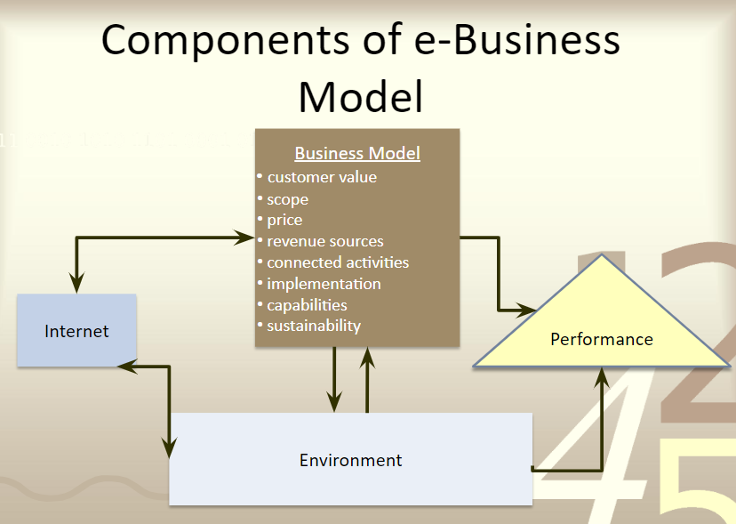

1. Customer value – What is customer value?

-Differentiation

* Product features
* Timing
* Location
* Service
* Product mix
* Linkages
* Brand name reputation

-Low cost

1. Scope

-Market segment /geographic area

* Businesses

-Different industries

-Sizes

-Technical sophistication

* Household

-Demographic

-Lifestyle

-Incomes

Example: an e-Business company that targets teenagers must decide how much of their customers’ needs it wants to meet.

1. Price

* Require good pricing strategy
  + Dynamic pricing

-Menu/ fixed pricing

-One-to-one bargaining

-Auction

-Reverse auction

-Barter – to trade without exchange of money

1. Revenue sources

* Determine the source of revenue
* Commission
* Interest
* The spread between the bid and the price of stocks

1. Connected activities- what and when

What

* Activities to perform must be consistent with customer value and scope
* Reinforce each other
* Gain advantage from industry success drivers
* Gain advantage from any distinctive advantages
* Gear towards building the image

When

* Market situation
* Competitors doing
* Customers demand

**Q9) Revenue model**

* Describes how the firm will earn revenue, generate profits, and produce a superior return on invested capital
* Terms financial model and revenue model often used interchangeably

Major types:

1. Advertising revenue model
2. Subscription revenue model
3. Transaction fee revenue model
4. Sales revenue model
5. Affiliate revenue model

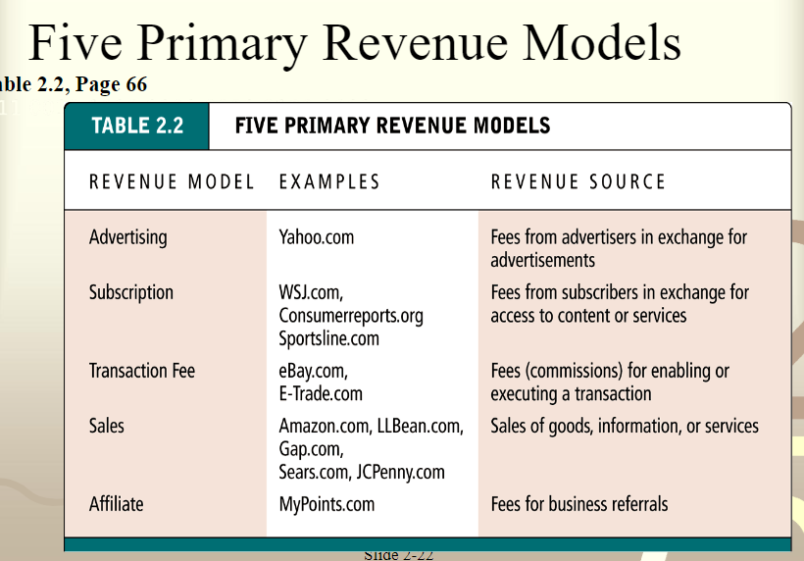

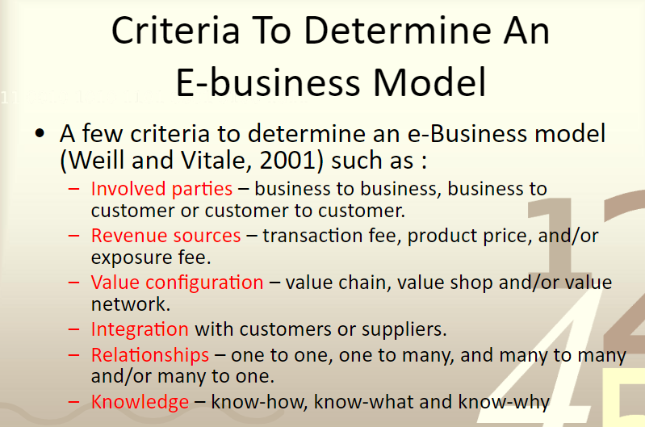

Following is from D15B PPT for MOD5

Overview of E - business

1. **What is e- business**

1.1)a company that does all or most of its transactions through the internet.

1.2) E-business (electronic business) is the conduct of online business processes on the web, internet, extranet or a combination thereof.

1.3) E-Business (electronic business) is any process that a business organization conducts over a computer-mediated network. Business organizations include any for-profit, governmental, or nonprofit entity. Their processes include production-, customer-, and internal- or management-focused business processes.

1.4)Electronic business (e-business) refers to the use of the Web, Internet, intranets, extranets or some combination thereof to conduct business.

1.5)E-business is similar to e-commerce, but it goes beyond the simple buying and selling of products and services online.

1.6)E-business includes a much wider range of business processes, such as supply chain management, electronic order processing and customer relationship management.

1.7)E-business processes, therefore, can help companies to operate more effectively and efficiently.

**2)Features of Online Business**

2.1)It is easy to set up

2.2)There are no geographical boundaries

2.3)Much cheaper than traditional business

2.4)There are flexible business hour

2.5)Marketing strategies cost less

2.6)Online business receive subsidies from the government

2.7)There are a few security and integrity issues

2.8)There is no personal touch

2.9)Buyer and seller don’t meet

2.10)Delivery of products takes time

2.11)There is a transaction risk

2.12)Anyone can buy anything from anywhere at anytime

2.13)The transaction risk is higher than traditional business

**3)Types of e- business**

**3.1)Business-to-Business (B2B)**

a)Transactions take place between two organizations. B)Producers and traditional commerce wholesalers typically operate with this type of electronic commerce.

c) it greatly improves the efficiency of companies.

**3.2)Business-to-Consumer (B2C)**

a)When a consumer buys products from a seller then it is business to consumer transaction.

b)People shopping from Flipkart, Amazon, etc is an example of business to consumer transaction.

c)In such a transaction the final consumer himself is directly buying from the seller.

3.3)Consumer-to-Consumer (C2C)

a)A consumer selling product or service to another consumer is a consumer to consumer transaction.

b)people put up ads on OLX of the products that they want to sell.

c)C2C type of transactions generally occurs for second-hand products.

d)The website is only the facilitator not the provider of the goods or the service.

**3.4)Consumer-to-Business (C2B)**

a)In C2B there is a complete reversal of the traditional sense of exchanging goods.

b)This type of e-commerce is very common in crowd-sourcing-based projects.

c)A large number of individuals make their services or products available for purchase for companies seeking precisely these types of services or products.

**3.5) Consumer-to-Administration (C2A)**

a)This model encompasses all electronic transactions conducted between individuals and public administration.

b)like in Education, disseminating information, distance learning, etc.

c)Social Security through the distribution of information, making payments, etc.

d)Taxes filing tax returns, payments, etc.

e)Health appointments, information about illnesses, payment of health services, etc.

**3.6)Business-to-Administration (B2A)**

a)all transactions conducted online by companies and public administration or the government and its various agencies.

b) these types of services have increased considerably in recent years with investments made in e-government.

**4) Characteristics of e-business**

**4.1)Ubiquity**

a)Since e-business is based on the internet it can be accessed from anywhere at any time.

b)E-business can not be stopped by physical space as people having an internet connection can easily reach the company’s websites and online stores from any corner of the world.

**4.2)24×7 Service Availability**

a)the service is available 24 hours and 7 days a week and it never stops.

b)It is not like traditional commerce where the stores or shops are only open for a limited time.

c)Customers can enjoy e-business services at any time such as viewing goods & services, interacting with sellers, placing orders, making payments, and so on which are not not possible in physical shop

**4.3)Easy To Set Up**

a)E-business is easy to set up as to start an e-business there is no need for physical space .

b)you just need a laptop or smartphone and an internet connection.

c)Being at the home, office, or any place you can easily start an electronic business and is also cheaper than a traditional business.

**4.5) Global Reach**

a)The reach of technology is boundary-less, and it reaches across national boundaries around the globe.

b) A firm launching its e-commerce website can easily be accessible to the rest of the world’s customers.

c) With e-business solutions, a company’s customers are equal to the total population of the world.

**4.6) Richness**

a)E-business has richness over traditional commerce.

b)The e-business communication channels are very rich. C)The content of messages provided by e-business such as text, video, photo, messaging, sounds, links, etc available for customers to know more about the goods and services they want to buy.

**4.7) No Geographical Boundaries**

a)The traditional business is located at some specific location and its reach is also limited.

b)But e-business has no geographical boundaries; it can easily reach around the globe from one even a very small corner of the globe.

**4.8)No Personal Touch**

a)There is no personal touch in e-business and e-commerce. B)Buyers and sellers can interact using telecommunications.. networks, discuss business deals, and complete the deals.

**4.9) Buyer and Seller Don’t Meet**

a)In e-business buyers and sellers just make contacts through electronic means they physically do not meet each other as happens in physical business.

b)They interact over the internet, make buying and selling orders, and the products are delivered through different delivery channels.

**4.10) Information Density**

a)E-business and e-commerce reduce information cost and raises the quality of information.

b)Customers and other stakeholders can easily get product information through websites, blogs, journals, and reviews, and they can easily compare which is better.

**4.11)Personalization**

a)E-business and e-commerce promote personalization. B)They provide marketing messages to each customer differently based on his or her past activities, name, interests, and purchase records.

c)Every customer gets a personalized message from the e-business websites that best match their past purchase activities.

**4.12)Inventory Management**

a)E-business increases companies’ productivity through inventory management.

b)The required information about sales reports, customer details, purchase details, and other transaction reports are readily available when needed.

**4.13) Non-Cash Payment**

a)In e-business/commerce the payments are made using debit cards, credit cards, digital wallets, and through different online payment mechanisms.

**4.14) Delivery Takes Time**

a)In the e-business/commerce realm the delivery of ordered products takes time.

b)It can be a couple of minutes, hours, or days.

c)It is not like traditional commerce where instant delivery is possible when payment is made. Here, customers have to wait for the delivery of their products up to the prescribed time

Concept of E-business,

Business Success through adoption of technology,

**5)Business success through the adoption of technology**

5.1)Before we go for technology there are certain factors or qualities which the person having the business should have for a successful business.

5.2)These factors are

a)Developing vision and strategy.

b)Developing and managing products and services.

c)Marketing and selling products and services.

d)Delivering services.

e)Managing customer service.

5.3) technology can now be used in all these fields for the enhancement of business

5.4) in case e-business technology is a must but by using the right type of technology in the right place time and money can be saved which in turn will increase the business

5.5) Technology helps increase the efficiency of systems, products and services.

5.6)It helps track and streamline processes, maintain data flow and manage contacts and employee records.

5.7) In fact, this increased efficiency in operation helps reduce costs as well as enable the business to grow rapidly.

5.8)Technology can be used in the fields of

**a) Communication**

a.1)Technology enables a faster, wider and more efficient means of communication.

a.2)This will include interactions within the team or with the clients, potential customers, investors or the general public. .

a.3)Video conferencing technologies, like Skype and Zoom, make meetings from across geographical borders convenient.

a.4)As for within your organization, an app like Slack or Asana can help you simplify communication within your team. You can use this to track projects, details on tasks, deadlines, etc., regardless of whether they work from under the same roof, or remotely.

a.5)Email, newsletters, social media, and other platforms are all equally essential resources for communication.

**b) Security**

b.1)With the rise in cyber-crime and data breaches, tight security is imperative for all businesses.

b.2)Today, all business assets are mostly stored in the cloud or on endpoints. This has made it necessary for companies to adopt strict measures to keep their data as well as that of their customers secure.

b.3) firewalls, domains, secured IP, HTTPS, tunneling, encryption, secured protocols are some of the means of security used

**c) Efficiency**

c.1)Technology helps increase the efficiency of systems, products and services.

c.2)It helps track and streamline processes, maintain data flow and manage contacts and employee records.

c.3)In fact, this increased efficiency in operation helps reduce costs as well as enable the business to grow rapidly.

**d)Employee assistance**

d.1)Most employees feel the need to use the latest technologies in performing their tasks with the belief that it will help them deliver the best results

d.2)Companies need to consider the cost-output relationship and provide suitable technology to enhance results.

**e)time and money**

e.1)There’s no doubt that technology helps businesses achieve more in less time, with no detriment to the quality of product or service.

e.2) In fact, technology is now performing repetitive tasks that were earlier performed by people. This helps by saving on employee costs, or having them work in areas where they are really needed.

e.3)Businesses need to have an in-depth understanding of technological tools in order to optimally leverage them.

e.4)Management information systems go a long way in helping companies track their data, sales, productivity levels and expenses.

e.5)Data can also identify areas of improvement as well as opportunities for growth.

e.6)Ably handling information systems will help businesses streamline administrative operations, reduce operation costs, innovate, enter new markets, improve customer service and create a competitive advantage for themselves in the market

**f) conclusion**

In e-commerce, technology has a significant role as it provides valuable marketing insights into customer preferences. It guides them into creating better marketing campaigns for business. This e-commerce technology also offers the automation and transfer of data management operations to boost performance.

information management for business Initiatives, Performance improvement

**6) Information management for business initiative**

**6.1)what is Information management (IM)**

a)It concerns a cycle of organizational activity as the acquisition of information from one or more sources, the custodianship and the distribution of that information to those who need it, and its ultimate disposal through archiving or deletion.

**6.2) IM and its ,its purpose**

The purpose of information management is to: design, develop, manage, and use information with insight and innovation. support decision making and create value for individuals, organizations, communities, and societies.

**6.3)IM stages**

Each of these steps, **gathering**, **storing**, **distributing**, and **deleting** are critical when responsible for a client's information management.

Taking these steps will help your client manage their information in a proper and secure way.

**6.4) the benefits of IM include**

a)Achieving strategic outcomes.

b)Identifying opportunities.

c)Growth and success.

d)Effective and informed planning (e.g. service delivery or disaster management)

e)Saving money/maximizing value.

f)Managing risk.

**6.5) how MI can be used for business initiatives**

a)Before launching the business the information of who can finance can be collected.

b)Location information for customers, product launching sites, raw material availability, transport means, all this can be got

c)IMS for customer database, sales database, competitive product and price database can be created and can be used for trend analysis

d)MIS can also have records of various product life cycle, various process life cycle which can be used for future study

f) MIS of disaster management data can help in taking early preventive measures in maintenance activities

g) MIS having information of MTTR( mean time to repair) and MTBF(mean time between failure) of systems, subsystems, units will help in smooth working of the system infrastructure

h) MIS of security issues list, the threats, attacks, vulnerabilities, security measures taken, issues solved etc information

**7) Performance improvement by e business**

E business always looks for improvement of its sales. for this various strategies are defined they are

**7.1)Understand your target audience**

a)To make the right decisions about your products and marketing activities, you need to understand your customers.

b)When you have a brick-and-mortar store, you can have conversations with your customers right there and find out what appeals to them.

c)When your customers are online, you have to proactively take steps to learn about them.

**7.2) Use analytics to learn how customers find your store**

a)You want to use your time and marketing resources wisely By using analytics tools such as Google Analytics to research how customers who make purchases are finding your store, thus you can then better focus your marketing efforts.

b)For example, if you get a lot of traffic to your cookware store from a blog post about healthy eating, you should write more content on that topic.

c)If almost all your sales are coming from Facebook ads, it may be worth it to invest in more advertising.

**7.3)Find your unique selling proposition**

a)What do you offer that no one else can? What is behind your store, your products, and yourself?

b)Once you know what makes you different, you need to shout it from the virtual rooftops. You can include it in your tagline, make it prominent on your home page, announce it in social media ads, and highlight it in your email marketing

**7.4) Simplify customer experience**

a)You want it to be as easy as possible for customers to find what they are looking for and then buy it.

b)If your analytics show a high number of people are visiting your site and leaving without buying, your customer experience may be the reason.

**7.5) Focus on customer service**

a)Customers value great service, thus Create a contact page on your website that clearly shows how to contact you. B)Include a phone number, email address, and chat link if you have one.

c)To help people get answers right away, add an FAQ page to your website.

**7.6)Provide a chat feature on your website**

a)Since the COVID-19 pandemic began, more customers have started to rely on chat to communicate with businesses. B)If you don’t have a chat feature, add one to your website and monitor it throughout the day.

**7.7)Create a simple checkout process**

a)While the checkout process is part of the user experience, it’s a big sticking point for many sales and deserves extra attention.

b)Offer a guest checkout option so customers can buy without filling in long forms.

c)Break up the checkout into multiple pages or an expanding page to keep from overwhelming the customer with buyer information fields.

**7.8)Select the right eCommerce platform for your needs**

a)By choosing a platform that has a simple process and management features, your customers can easily navigateyour store, navigate your site, Then you can spend more time growing your business instead of growing your store.

b)If you don’t need a full website, choose a platform such as Square Online Checkout, which allows customers to pay online without you needing to have a full website

**7.9)Create content**

a)When people have a question, they head to Google and look for the answer.

b)By creating content that provides interesting and relevant information to your customers, you can help people find your eCommerce store

**7.10)Put customer reviews on product pages**

a)While it may feel scary to let customers share both positive and negative comments about your products on your page, adding customer reviews can increase your sales.

b) if a product consistently gets poor reviews, it’s a sign that you should either address the issues or discontinue the product.

c)When adding reviews, let customers leave both a star rating and a comment.

d) Make it as easy as possible for customers to write reviews. Even better, use an eCommerce platform with the feature built in.

**7.11)Use responsive design**

a)With 1 in 4 customers using mobile devices to make purchases, your online store should be easy to navigate and purchase from when using a mobile device.

b)Use an eCommerce platform that has responsive design, which means it makes websites render properly on a smartphone.

**7.12)Showcase your products with high-quality photos**

a)Photos matter. If necessary, invest in a professional photographer to take high-quality pictures that show your products’ features. Make sure the photos accurately represent the products.

**7.13)Connect with customers through email marketing**

a)Email marketing may seem old-school, but it works.

b) By using an eCommerce platform that automatically collects email addresses, you can easily share sales, new products, and tips with your customers.

c) You can also collect more email addresses by offering a subscription option to your blog or offering a discount code. d)Consider creating an email newsletter so your customers hear from you on a regular basis.

Introduction to various collaborative partnerships

**8)Introduction to various collaborative partnership**

**8.1)what it is.**

a)Collaborative partnerships are agreements and actions made by consenting organizations to share resources to accomplish a mutual goal.

b)Organization can be an entity such as a company, an institution, or an association

c) sharing resources means all the materials available in our environment which are technologically accessible, economically feasible and culturally sustainable and help us to satisfy our needs and wants

**8.2)steps to build an effective and sustaining collaborative partnership**

**a)Step1:Determine the need and readiness**

Is there a need for collaboration?

Is there already a collaboration elsewhere doing something similar?

**Step 2: Recruit the right people and organizations**

Gather all potential partners together for discussion about elements of the collaboration.

Get commitment for proceeding from those agreeing to partner

**Step 3: Assess resources needed**

Identify the skills and competencies needed to manage and support the collaboration

**Step 4: Determine the structure of the collaborative partnership**

Ensure there is clarity among partners as to the mission, values and principles that will guide the collaborative partnership

**Step 5: Develop a communication strategy**

Set up an effective communication plan between partners

**Step 6: Agree on and develop an action plan**

Develop an action plan to meet goals/objectives of collaborative partnership

**Step 7: Identify risk factors for the collaboration**

Make a list with partners of potential risks to the collaboration

**Step 8: Create an open environment**

Identify factors which create and build trust

**Step 9: Celebrate successes**

After all the hard work, remember the value of celebrating your success with the entire team involved in your collaboration.

**8.3)Types**

**a)Internal collaboration**

a.1) individuals or groups within an organization work together and share knowledge.

a.2)This can exist in many formats and across various levels of the organization.

a.3)it is beneficial because it promotes transparency, helping members across the organization share information and ideas to pursue goals and complete tasks

**b) External collaboration**

b.1)it represents sharing knowledge or working with individuals outside the organization.

b.2)it may include customers, vendors, other organizations and competitors.

b.3)Organizations can use it for several purposes that support the business, such as gathering feedback or launching a new product or initiative.

b.4)An organization often seeks external collaborators because they can offer something unavailable internally.

**c)Team collaboration**

c.1)it is one of the most common types of internal collaboration.

c.2)Organizations often divide employees into different departments based on their roles or responsibilities.

c.3)For example, an organization may have sales, human resources, operations and finance departments.

c.4)These departments may have sub-teams, such as the lead generation and customer success teams within a sales department.

c.5)In a team, everyone has assigned roles and works toward the same goals, sharing knowledge or information relevant to those goals

c.6) Teams often also have a leader, such as a manager, who oversees the work completed by its members.

**d)Cross-departmental collaboration**

d.1)it is another type of internal collaboration in which individuals or groups from different areas of an organization work together.

d.2)Typically, one of the partners provides resources or knowledge that the other department needs.

d.3)They may need to create these partnerships for specific projects, or individuals can seek guidance on a task by asking someone with relevant expertise from another department.

**e)Community collaboration**

e.1)it is when individuals with a shared interest work together.

e.2)its goal is to learn and share knowledge rather than completing a business task or project.

e.3)However, when they gain information or insights from a member of their community, they may bring it back to their team or workplace to support their work.

e.4)Individuals in an organization may find this type of collaboration internally and externally.

**f)Virtual collaboration**

f.1)it enables individuals and teams to work together even when they're not in the same location.

f.2)This type is essential for remote teams where coworkers don't work in an office, though many in-person offices also benefit from virtual collaboration tools

f.3)For example, many offices use chat software or email to send messages internally.

f.4)These tools enable individuals to communicate without leaving their desk if their colleague works in another area of the office.

**g) Cloud collaboration**

g.1)it represents another form of virtual collaboration.

With cloud tools and software, employees can work on the same document from different locations

g.2) These documents update in real time, allowing collaborators to share, review and edit them and see the latest changes as they occur.

g.3)This type is also effective for hosting and sharing large files within the organization.

g.4)Teams can create cloud-based folders, allowing them to gather and share documents in a central location for all necessary parties to access.

**h) Strategic alliance**

h.1) type of external collaboration that occurs when two or more organizations work together toward a common goal.

h.2)They may enter these agreements for short- or long-term purposes

h.3)Some partnerships involve binding agreements, which establish each parties' responsibilities in the relationship. h.4)Failure to meet those responsibilities can lead to conflicts.

h.5)In these collaborations, the business partners share their knowledge and resources, often supplementing what the other doesn't have or offer.

**i)Network collaboration**

i.1)With network collaboration, people may work with others in pursuit of individual goals.

i.2)These networks can exist in person or through digital formats, and the members of the network may not always know one another personally.

i.3) People can contribute to this by sharing information or expertise for others to use for their own benefit.

1.4)Eventually, network members may even develop stronger relationships and rely on one another to help with specific goals or tasks.

E-commerce: Sectors of ecommerce, B to C, B to B and C to C ecommerce,

**9) E commerce**

**9.1) what is it**

a)E-commerce (electronic commerce) is the activity of electronically buying or selling of products on online services or over the Internet

b)There are three areas of e-commerce: online retailing, electronic markets, and online auctions.

c)E-commerce is supported by electronic business

9.2) types

**a)Business-to-business (B2B)**

a.1)B2B e-commerce refers to the sale of goods or services between businesses via an online sales portal.

a.2)While sometimes the buyer is the end user, often the buyer resells to the consumer.

a.3) This type of e-commerce typically applies to the relationship between producers and wholesalers; it may additionally remain applied to the relationship between the producers or the wholesalers and the retailers themselves.

a.4)B2B typically requires more venture capital and a longer sales cycle, but results in higher order value and more recurring purchases.

**a.5)The advantages of B2B**

**1)Convenience:** While companies can sell through physical storefronts or take transactions by phone, B2B commerce often takes place online, where companies advertise their …… products and services, allow for demonstrations and make it easy to place bulk orders. Sellers also benefit from efficient order processing thanks to this digital transaction model.

**2)Higher profits:** B2B companies often sell their items in wholesale quantities, allowing buyers to receive a good deal and restock less often. Larger order numbers lead to higher potential sales and additional profits for B2B sellers. At the same time, the ease of advertising to other businesses through B2B websites can help cut marketing costs and boost conversion rates.

**3)Huge market potential:** From business software and consulting services to bulk materials and specialized machinery, B2B sellers can target a large market of companies across industries. At the same time, they have the flexibility of specializing in an area like technology to become a leader in the field.

**4)Improved security:** Since contracts are a common part of B2B commerce, there's some security for both buyers and sellers in that there's less concern that one will pay and the other will deliver goods as promised. Since sales usually get tracked digitally, it's also more secure in that B2B sellers can track and monitor their financial results.

**a.6) The disadvantages of B2B**

**1)More complex setup process:** Getting started as a B2B retailer takes work to figure out how to get customers who stay dedicated and make large-enough orders. This often requires thorough research to advertise to potential businesses, set up a custom ordering system and adapt quickly when sales are underwhelming;

**2)Limits to sales**: While B2B companies can sell a lot, they do miss out on potential sales to individual customers. The smaller pool of business buyers and the need to negotiate contracts can put some limits on profits, especially when the company loses key buyers to other competitors;

**3)Need for B2B sellers to stand out**: At the same time, the B2B market has many companies competing and selling similar products and services. Sellers often need to cut prices and find special ways to grab companies' attention to succeed in the market;

**4)Special ordering experience needed:** B2B companies selling online need to put much effort into designing a website and ordering system that buyers find easy to use. This means presenting product and service information clearly, offering online demos or consultations and using order forms with appropriate options for quantities and any special customization needed.

Complex payment process: B2B online payment solutions are both time-consuming and expensive for both parties. The buyer has to be credit checked, they'll often negotiate payment terms and trade discounts and the business will manually have to create a custom invoice.

**b) business-to-consumer (B2C)**

b.1) it is a retail model where products move directly from a business to the end user who has purchased the goods or service for personal use.

b.2) model, which involves exchanging goods and services between businesses and consumers.

b.3)The term B2C is applicable to any business transaction where the consumer directly receives goods or services, such as retail stores, restaurants and doctor's offices.

b.4) Most often it refers to e-commerce businesses, which use online platforms to connect their products with consumers.

b.5) B2C…common types companies

**a)Direct sellers**.:The most common and familiar e-commerce business, where customers purchase directly from the seller.

**b)Intermediaries:** Rather than offering their own products or services to shoppers on their site, these e-commerce companies offer a platform for C2C (consumer-to-consumer) markets, connecting buyers with independent sellers. Intermediary companies often profit by charging a small percentage of each sale from vendors.

**c)Advertising-based:** These e-commerce companies use traffic-driving strategies like Content marketing to connect shoppers with relevant advertisements for products and services. In this scenario, the website profits from selling advertising space.

**e)Community-based:** they use online communities centered around specific identities or interests and information such as demographic data and geographic location to connect website-goers with targeted ads.

**f)Fee-based:** These e-commerce businesses require a paid subscription in exchange for unrestricted access to their content.

**g)Brick-and-mortar**: A physical location of a business or retail establishment where consumers can enter the store, touch and hold the merchandise and buy products or services in-person.

**c)Benefits of B2C E-commerce**

c.1)B2C e-commerce models have been associated with a number of potential benefits, including:

**c.2)Globalization:** Larger-scale B2C businesses frequently have very large target audiences. Therefore, advertisements and marketing campaigns can reach millions of potential customers, via the internet and social media.

**c.3)Relatively low cost:** E-commerce B2C models can cut down on operational and physical infrastructure costs.

**c.4)Customer personalization:** B2C businesses can directly market to consumer segments and niche target audiences, allowing companies to personalize their marketing for individual consumers.

**c.5)Direct customer experience:** Both online and brick-and-mortar businesses have complete control over user experiences. This control can lead to better customer service, increased cross-selling and customer loyalty.

**c.6)Customer data.**:Valuable customer data -- such as sales conversion stats, email addresses for marketing automation, analytics, customer behavior patterns, geographic regions and psychographics can strengthen a business's marketing strategy and provide insights about users.

d) examples of physical B2C businesses include Doctors' offices, Restaurants, Convenience stores, Hair and nail salons, Spas, Pet groomers

**e)Limitations of B2C**

**e.1)Highly Competitive Market;** B2C presents a very competitive market. Many B2C companies are already operating in almost every conceivable product category, so it can feel overwhelming when starting a new business.

It brings price competition, too. A B2C company must be able to compete against established businesses and find an effective way to attract customers despite this.

**e.2) Finding and Retaining Customers:**Due to the huge competition, businesses need to find ways to differentiate their products or services from their competitors. They need to have a good marketing strategy to make sure that their target consumers are reached. Marketing should understand the details about their customers, such as who they are, what is important to them, how they are inspired, and how they purchase and receive the types of product one is selling.

**e.3)Lower Margins:**  Products sold in a B2B business are cheaper. The business has to find alternative ways to gain back the lost revenue by focusing on quantity over quality.

**c)Customer to customer (C2C)**

**c.1) what it is**

1)It is a business model whereby customers can trade with each other, typically in an online environment. Two implementations of C2C markets are auctions and classified advertisements.

2) markets provide a way to allow customers to interact with each other.

3) electronic commerce involves the electronically facilitated transactions between consumers through electronic commerce involves the electronically facilitated transactions between consumers through some third party. A common example is an online auction, in which a consumer posts an item for sale and other consumers bid to purchase it; the third party generally charges a flat fee or commission. The sites are only intermediaries, just there to match consumers. They do not have to check the quality of the products being offered.

4)marketing is the creation of a product or service with the specific promotional strategy being for consumers to share that product or service with others as brand advocates based on the value of the product.

5)The investment into conceptualizing and developing a top-of-the-line product or service that consumers are actively looking for is equitable to a retail pre-launch product awareness marketing.

**c.2) Advantages**

1)Customers can directly contact sellers and eliminate the middleman.

2) Anyone can now sell and advertise a product in the convenience of one's home and enable one to easily start a business.

3) a wide variety of products can often be found on auction sites such as eBay, including second-hand goods.

4)Since the majority of these sales occur over the internet, sellers can reach both national and international customers and greatly increase their market.

5)Feedback on the purchased product is often requested to aid both the seller and potential customers.

6)The actual buying and searching process is simplified and search costs, distribution costs, and inventory costs are all reduced.

7) the transactions occur at a swift rate with the use of online payment systems such as PayPal.

**c.3)Disadvantages**

1)Although online auctions allow sellers to display their products, there is often a fee associated with such exhibitions.

2)Websites may also charge a commission when products are sold.

3) With the growing use of online auctions, the number of internet-related auction frauds has also increased.

4)For instance, a seller may create two accounts on an auction site. When an interested buyer bids for an item the seller will use another account to bid on the same item and thus, increasing the price. Consequently, many users have purchased products at unnecessarily inflated prices.

5)Identity theft has become a rising issue. Scam artists often create sites with popular domain names such as "ebay" in order to attract unknowing eBay customers. These sites will ask for personal information including credit card numbers. Numerous cases have been documented in which users find unknown charges on their credit card statements and withdrawals in their bank statements after purchasing something online.

**4) Key Factors for Success in Ecommerce**

4.1) Brand name : Create a memorable brand name: Like Amazon, eBay, Flipkart. Make your brand consistent. Avoid changing your domain name as Your customers are familiar with your website, thus changing a domain name will make your site less visible in search engines.

4.2) Design of the store :make Attractive design, Create an easy-to-use interface, Transparency in information

4.3) Search Engine Optimization (SEO); Make the site SEO-friendly, Use relevant keywords. Mobile responsiveness.

4.4) Multichannel marketing :Promote on Social Media. Do Content marketing and Email marketing:

4.5) Personalized buying experience :Customer Satisfaction is the key, Make the customer work simple, Offer discounts & deals

4.6) Multiple payment methods offer online shopping and

Online payment, Offer third-party payment

4.7)Easy check-out process

4.8) Customer service: Provide customer service, Get regular feedback, Answer all the customers’ queries

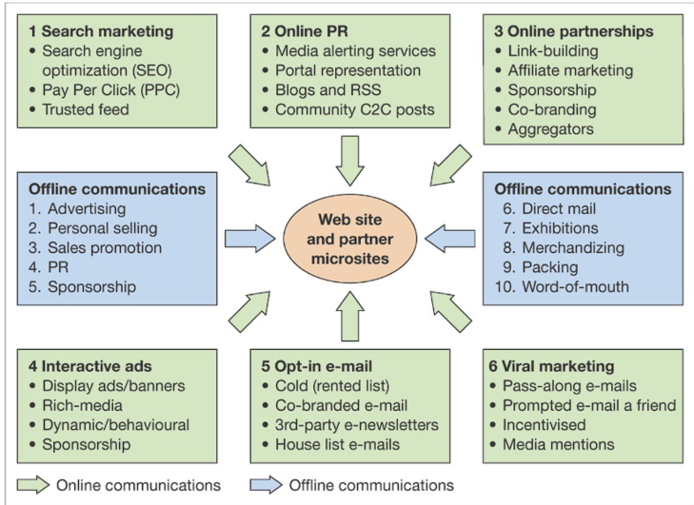

**Module 6: Strategic initiatives for Technology**

Customer Relationship Management: The evolution of CRM, functional

areas of CRM, contemporary trends - SRM, PRM AND ERM, Future Trends

of CRM Enterprise Resource Planning: Core and Extended ERP; components

of ERP system; Benefits and Risks of ERP implementation Supply Chain

Management: Meaning, definition, importance, and characteristics of SCM,

Elements of SCM, Push & Pull supply chain model, Use of e-business to

restructure supply chain, Supply chain management implementation

Procurement: Meaning and advantages of e –procurement, Types& Drivers

of e- procurement, Components of e-procurement systems, Implementation of

eprocurement

**1. What is CRM**

a) Customer relationship management (CRM) is the combination of practices, strategies and technologies that companies use to manage and analyze customer interactions

and data throughout the customer lifecycle.

b) Customers lifecycle…In CRM, customer lifecycle is a term used to describe the progression of steps a customer goes through when considering, purchasing, using and

maintaining loyalty to a product or service.

b.1) customer lifecycle into five distinct steps: reach, acquisition, conversion, retention and loyalty.

customer lifecycle into five distinct step:

**Reach**: customer develops awareness of a company’s product or service. The awareness can come from social media, advertisements, by word of mouth from friends or from other means.

**Acquisition**: In this stage, customers learn more about the company’s offerings from visits to the website, or by conversations with sales representatives or by experiencing

or testing products in a store.

**Conversion**:This is the stage where customers purchase a product or service. It is important to understand the customers’ key purchasing criteria, then position ……..

systems can also give customer-facing staff members detailed information on customers' personal information, purchase history, buying preferences and concerns

products to have a clear advantage over drive sales growth.

**Retention**: after acquiring the new customer, the focus is to help the customer derive satisfaction and value from the product and services. A company can achieve this by using surveys and phone calls to understand customer satisfaction and address any issues that arise.

**Loyalty**: satisfied customers continue using the product or continue renewing their term for subscription-based offerings. Loyal customers may opt for additional services

or purchase higher-priced options.

b.2) Advantages of Customer Relationship Management

Enhances Better Customer Service: capability to add a personal touch to existing relationships between the business and the customers. It is possible to treat each client

individually rather than as a group, by maintaining a repository on each customer’s profiles.

Facilitates discovery of new customers: CRM systems are useful in identifying potential customers. They keep track of the profiles of the existing clientele and can use them to

determine the people to target for maximum clientage returns.

Increases customer revenues : CRM data ensures effective co-ordination of marketing campaigns. It is possible to filter the data and ensure the promotions do not target those who have already purchased particular product

Enhances effective cross and up selling of products Cross: selling involves offering complimentary products to customers based on their previous purchases. On the other

hand, up – selling involves offering premium products to customers in the same category.

Simplifies the sales and marketing processes: A CRM system facilitates development of better and effective communication channels. Technological integrations like

websites and interactive voice response systems makes work easier for the sales representatives as well as the organization.

Makes call centers more efficient :Targeting clients with CRM software is much easier since employees have access to order histories and customer details. The software helps the organization’s workforce to know how to deal with each customer depending upon their recorded archives.

.Enhances customer loyalty :CRM software is useful in measuring customer loyalty in a less costly manner. In most cases, loyal customers become professional recommendations of the business and the services offered. Builds up on effective internal communication: A CRM strategy is effective in building up effective communication within the company. Different departments can share customer data remotely, hence enhancing team work.

Facilitates optimized marketing: CRM enables a business understand the needs and behavior of their customers. This allows them to identify the correct time to market their product

**2. Functional Areas of CRM**

Lead management….Lead management is the process of gathering, analyzing, and managing information about a potential customer. It is a crucial part of the CRM system.

Marketing…..The marketing department in any organization plays an important role in increasing the number of sales. A marketing department may target a specific audience with different kinds of promotions or may target each individual customer differently.

Sales…..CRM systems can also help the sales department to keep track of information about leads. For one thing, it helps the sales department to manage their activities more efficiently.

Reporting and analytics ….CRM systems also allow the sales department to perform more detailed reporting. And, it also helps them to create clearer and more accurate

reports. So, they can identify and fix the loopholes in your sales process.

Customer service….One of the biggest advantages of CRM is that it helps improve customer service as well.

CRM can help you organize your customers’ information in a better way. So, it becomes easier for the customer service team to handle their calls without any confusion.

**3) Main component of CRM System.**

3.1)Database: A database is the most important

component of the CRM system, that stores client

information and other data required by organizations to

carry out their business activities. ...

3.2) Data Warehousing. ... It contains all the historical

records generated by other components in this system. For

example Database and Business Intelligence tools etc.

3.3) Data Mining Tools. ... Data mining is another

important component of a CRM system that analyzes

large volumes of data stored in databases for extracting

valuable information. It is used to identify the potential

customers, the most profitable customers, and to make

strategic decisions regarding sales and marketing.

3.4) Business Intelligence Tools. ... they are used by

organizations to understand customer behavior, market

conditions, sales performance, product trends, etc.

Thereby helping them to increase their sales revenues and

customer loyalty.

3.5) Social Media Network….Social Media Networking

tools are used by organizations to promote their products

and services, market their brands, track customer

behavior, and do other business-related activities. It helps

in understanding how people perceive the organization,

what they like or dislike about the products or services

offered by them. .

3.6) Automation and AI……. Automation and AI will be

increasingly valuable to CRM platforms in the future. ...

3.7) Personalization. ...NLP

3.8) IoT. ...communication

3.9) Social media… social analytics

3.10) Organizational trends…. utilizing the above CRM

innovation trends, such as AI, Process automation, Data

integration, and Blockchain, have the potential to

immensely improve their customer experiences.

**4. contemporary trends - SRM, PRM AND ERM,**

Supplier relationship management (SRM) – focuses on keeping suppliers satisfied by evaluating and categorizing suppliers for different projects, which optimizes supplier selection.

Partner relationship management (PRM) – focuses on keeping vendors satisfied by managing alliance partner and reseller relationships that provide customers with the optimal sales channel.

Employee relationship management (ERM) – provides employees with a subset of CRM applications available through a web browser.

GPT se difference daal raha. End moment pe Ez padta samajhne ko

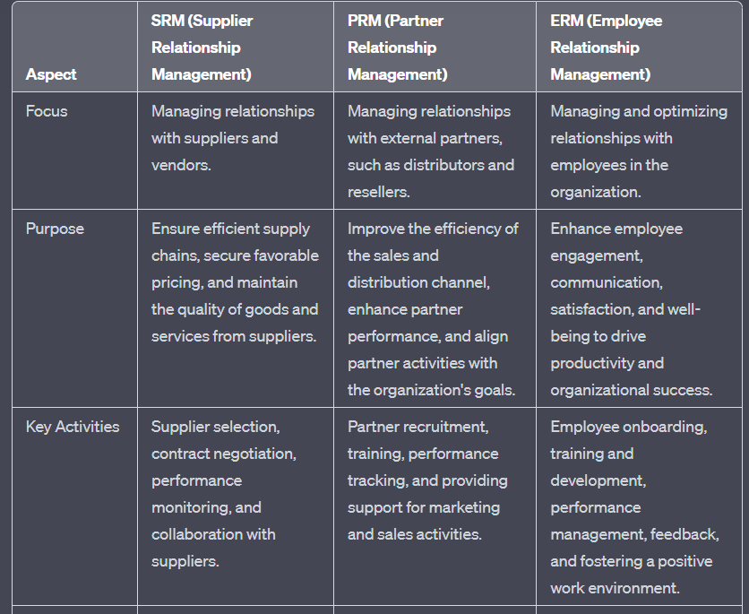

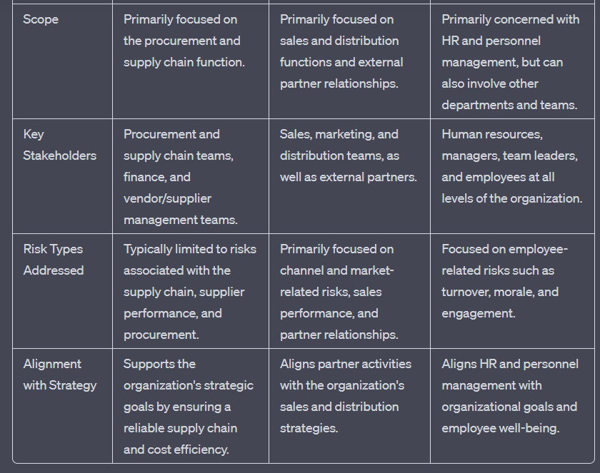

**5. Future Trends of CRM**

CRM Future Trends:

* CRM applications will change from employee-only tools to tools used by suppliers, partners, and even customers
* CRM will continue to be a major strategic focus for companies
* CRM applications will continue to adapt wireless capabilities supporting mobile sales and mobile customers
* CRM suites will incorporate PRM and SRM modules

**6. Enterprise Resource Planning: Core and Extended ERP;**

4.1) it is a platform which the companies use to manage

and integrate the essential parts of their businesses.

4.2)Many ERP software applications are critical to

companies because they help them implement resource

planning by integrating all the processes needed to run

their companies with a single system.

4.3)An ERP software system can also integrate planning,

purchasing inventory, sales, marketing, finance, human

resources, and more.

4.5) KEY TAKEAWAYS

a)ERP software can integrate all of the processes needed

to run a company.

b)ERP solutions have evolved over the years, and many

are now typically web-based applications that users can

access remotely.

c)benefits of ERP include the free flow of communication

between business areas, a single source of information,

and accurate, real-time data reporting.

d)ERP applications, a company can choose from, and

most can be customized.

e)An ERP system can be ineffective if a company doesn't

implement it carefully.

4.6) Understanding

ERP can be thought as the glue that binds together the

different computer systems for a large organization.

Without an ERP application, each department would have

its system optimized for its specific tasks.

With ERP software, each department still has its system,

but all of the systems can be accessed through one

application with one interface.

4.7) What Does ERP Do?

ERP applications also allow the different departments to

communicate and share information more easily with the rest of the

company.

It collects information about the activity and state of different

divisions, making this information available to other parts, where it

can be used productively.

ERP applications can help a corporation become more self-aware by

linking information about production, finance, distribution, and

human resources together.

As it connects different technologies used by each part of a

business, an ERP application can eliminate costly duplicates and

incompatible technology.

The process often integrates accounts payable, stock control

systems, order-monitoring systems, and customer databases into one

system

4.12) core and extended ERP …

.a) The core ERP components include Accounting and Finance,

Production and materials management. Whereas, Human Resources.

Business Intelligence, Customer Relationship Management, Supply

Chain Management and Ebusiness are included in the extended ERP

components.

b)Sales order management intersects with several core ERP

components, including accounting and financial management,

CRM, inventory management, warehouse management and logistics

management.

c)Extended ERP components include…Business intelligence. Customer relationship management.Supply chain management.

**7. Components of ERP system;**

4.10) ERP system components,

They are also known as modules in modular ERP systems, are

specialized applications that handle specific business functions.

They’re the building blocks of a centralized ERP system database,

designed to seamlessly work together to provide a comprehensive

view of an organization’s data and processes.

4.11) ERP system components types

a) Accounting and Financial Management…..Serving as a

centralized platform for managing all financial activities, accounting

and financial management is generally considered to be the most

important component of an ERP system. Within this component are

tools that businesses can use to track, store and analyze various

financial elements, including accounts payable (AP), accounts

receivable (AR), the general ledger (GL), budgets and forecasts.

b)Human Resources (HR)……Human resources, or human capital

management (HCM), is essential to managing a business’s

workforce. The HR component of an ERP system offers tools that

streamline HR tasks, such as recruitment, hiring, employee

management, performance evaluation and payroll processing .

c)Customer Relationship Management (CRM)….The CRM

component of an ERP system collects, organizes and analyzes

customer and prospect information, such as contact details, sales

history and service records, in one centralized repository. This data

can then be used to enhance interactions with customers, improve

relationships, automate key processes and provide important

insights

d)Business Intelligence (BI)…..this component makes it easy for

businesses to analyze large volumes of raw data from various

sources within an ERP system, from financial management to

warehouse management and everything in between. This broad

perspective enables them to track correlations and dependencies

among different aspects of their organizations to support

organizational alignment

e)Supply Chain Management (SCM)…SCM encompasses all of the

activities involved in turning raw materials into finished products

and delivering them to partners or customers. In an ERP system, an

SCM component tracks the movement of materials and goods

throughout the supply chain, from procurement to last-mile

delivery. SCM components can also manage product returns,

refunds and replacements.

f) Manufacturing and Logistics Management… ERP systems

generally offer some type of manufacturing operations management

software, such as production management systems, demand

planning capabilities or third-party logistics managers. These tools

help manufacturing teams plan and monitor production

**8. Benefits and Risks of ERP implementation**

4.8) Benefits of Enterprise Resource Planning

a) Businesses employ ERP for various reasons, such as expanding,

reducing costs, and improving operations. The benefits sought and

realized between companies may differ; however, some are worth

noting.

b)Improves Accuracy and Productivity

c) Integrating and automating business processes eliminates

redundancies and improves accuracy and productivity. In addition,

departments with interconnected processes can synchronize work to

achieve faster and better outcomes.

d)Improves Reporting….Some businesses benefit from enhanced

real-time data reporting from a single source system. Accurate and

complete reporting help companies adequately plan, budget,

forecast, and communicate the state of operations to the

organization and interested parties, such as shareholders.

e) Increases Efficiency….ERPs allow businesses to quickly access

needed information for clients, vendors, and business partners. This

contributes to improved customer and employee satisfaction,

quicker response rates, and increased accuracy rates. In addition,

associated costs often decrease as the company operates more

efficiently.

f) Increases Collaboration….Departments are better able to

collaborate and share knowledge; a newly synergized workforce can

improve productivity and employee satisfaction as employees are

better able to see how each functional group contributes to the

mission and vision of the company. Also, menial and manual tasks

are eliminated, allowing employees to allocate their time to more

meaningful work.

g) ERP Weaknesses….An ERP system doesn't always eliminate

inefficiencies within a business or improve everything. The

company might need to rethink how it's organized or risk ending up

with incompatible technology.

4.9) ERP Weaknesses….

ERP systems usually fail to achieve the objectives that influenced

their installation because of a company's reluctance to abandon old

working processes. Some companies may also be reluctant to let go

of old software that worked well in the past. The key is to prevent

ERP projects from being split into smaller projects, which can result

in cost overruns

4.11) risk in implementation of ERP system …

a)Poor project management and planning… can lead to ERP

implementation failure. A lack of clear timelines and milestones can

cause confusion between team members. This can result in delays

and budget overruns, among other downsides.

b) Inadequate user training and support..Employees may find it hard

to adapt to the new system– which leads to declined productivity.

Also, if they are not trained properly, they may be reluctant to use

the ERP system or may use it incorrectly.

c)Resistance to change from employees…. It’s quite typical for

employees to resist changes that may impact their job roles or

existing processes. Also, resistance to change can lead to delays in

the implementation and even project failure.

c) Limited stakeholder involvement…. If key stakeholders and

decision-makers are not involved in the process– it can lead to

future problems and failed implementation

d) Lack of alignment between ERP system and business

processes…..This usually happens when the ERP software is not

tailored to fit the business’s specific needs. This can result in

inefficiencies, data inaccuracies, and decreased productivity.

e)Data quality and integrity issues..When data is migrated from

legacy systems to the new ERP system, it can result in

inconsistencies, data loss or corruption. This will lead to inaccurate

reporting and reduced productivity.

**9. Supply Chain Management: Meaning, definition, importance, and characteristics of SCM,**

a)At the most fundamental level, supply chain management (SCM) is management of the flow of goods, data, and finances related to a product or service, from the procurement of raw materials to the delivery of the product at its final destination.

b)The five most critical phases of SCM are planning, sourcing, production, distribution, and returns. A supply chain manager is tasked with controlling and reducing costs and avoiding supply shortages.

c)In management has five major functions. These include purchasing, operations, logistics, resource management, and information workflow Good supply chains perform these functions in a way that meets the wants and needs of final consumers efficiently.

**Functions of SCM**

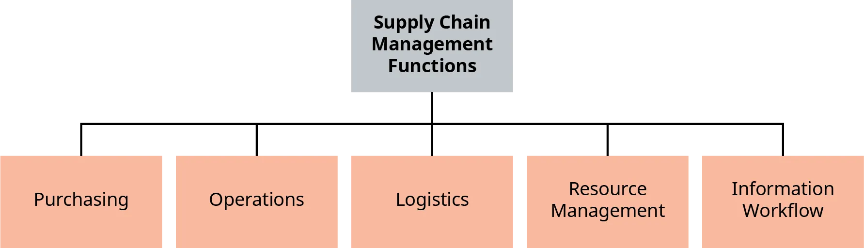

a)Purchasing... process of buying materials needed to manufacture products. These materials are purchased from suppliers, who must be able to deliver them in accordance with the manufacturer’s timeline. Therefore, the manufacturer’s companies and suppliers must communicate and coordinate to ensure timely delivery of materials.

b)Operations…Operations is everything a company does on a day-to-day basis to run a company. Before a company purchases the needed materials and begins production, it must forecast demand for its products. Forecasting involves anticipating or projecting how many units of a product will be sold during a given period.

c)Logistics..Logistics is a function that involves the coordination of all supply chain activities, such as warehousing, inventory management, and transportation. Companies along the supply chain must communicate effectively to ensure that products reach………

d) Resource Management..it is the planning, organizing, and controlling of resources. Resources include the labor, the raw materials, and the technology that are required to move products from their raw material phase to finished goods available for consumption. Effective supply chain management requires the right allocation of these resources to the right supply chain activities to optimize the entire system.

e) Information Workflow..it is a supply chain management function that relates to what and how information moves between members of the supply chain. If information doesn’t flow effectively or communication is poor, the entire process can suffer as a result of disruptions, delays, and mistakes.

**SCM advantages**

1. Better collaboration…leads to proper information flow , thus better collaboration between departments, other companies
2. Improved quality control…Companies that have greater control over not only their direct suppliers but also their suppliers’ suppliers benefit from improved quality control. Implementing standard minimum quality criteria, for instance, enables direct suppliers to identify and partner with secondary suppliers that meet those requirements.
3. higher efficiency rate… Having real-time data on the availability of raw materials and manufacturing delays allows companies to implement backup plans, such as sourcing materials from a backup supplier, preventing further delays.
4. Keeping up with demand…. Supply chain leaders with access to real-time, accurate information and integrated data can better predict demand and readily respond to changing market conditions to avoid challenges like the bullwhip effect.
5. Shipping optimization… Due to rising costs, shipping optimization is a priority for supply chain leaders. Identifying the most efficient shipping methods for small parcels, large bulk orders and other shipping scenarios helps companies get orders to customers faster while minimizing costs.
6. Reduced overhead costs..With more accurate demand predictions, companies can reduce the overhead costs associated with storing slow-moving inventory by stocking less low-velocity inventory to make room for higher-velocity, revenue-producing……
7. Reduced overhead costs.inventory. Warehouse fulfillment costs contribute significantly to overhead. Reduce these costs by optimizing your warehouse layout, adopting the right automation solutions to improve productivity and implementing a better inventory management system.
8. Improved risk mitigation…Analyzing big-picture and granular supply chain data can reveal potential risks, enabling companies to put backup plans in place to readily respond to unexpected circumstances. By taking proactive action, rather than reacting to supply chain disruptions, quality control issues or other concerns as they arise, companies can avoid negative impacts.
9. Improved cash flow.. Implementing more cost-effective solutions to eliminate wasteful spend and reducing overhead costs also contribute to positive cash flow.

**Characteristics of SCM**

**1. Flexibility**

Agility has always been important in supply chains. This trait has to trickle down to next generation supply chains, as they should be able to react to sudden changing circumstances in the operating environment. Any kind of unpredictable and devastating incident, such as a natural disaster, medical epidemic, political or economic instability, has the potential to overthrow supply chains. However, when they are flexible, have a strong risk assessment program, intelligent decision support systems and are demand driven, next gen supply chains can thrive in even the most challenging and competitive environments.

**2. Speed of Delivery**

Speed is of the essence of the next generation of supply chains. It will be more and more critical for supply chains to be able to respond to demands as quickly as they can, in order to ensure quick delivery for retailers and other key members of the supply chain. Companies will want to have a stock of products as soon as they are needed and they will also want to move more stock in a shorter period of time.

**3. Global Reach**

Long gone are the days when companies could locally limit the delivery of their products. Thanks to the Internet, you can expand supply chains on a global scale. At the same time, it is possible for global supply chains to react at a local level. Next gen supply chains must know how to create global hubs that are not only effective, but can also supply products locally without needing to transport them across the world for just a few orders.

**4. Optimized Inventory**

The trick with efficient inventory management is that you should have just the right amount of stock in the warehouse. Having too much will result in expired and unsold stock, while too little will almost always assure that you don’t have enough stock when it is urgently needed. This calls for optimizing inventory so that your supply can always meet the demand. The quantity of stock must be dictated by the current consumer behavior, buying trends, and local demand for the product. One way you can optimize inventory in any supply chain is by incorporating various tools, such as industrial weighing scales and truck scales. Innovative shipping techniques must also be employed to speed up the delivery process.

**5. Go Green and Sustainable**

Try to have a green supply chain which does not impact the environment negatively. Ensure that you don’t put any kind of pressure on the environment during any stage of the supply chain. At the same time, make sure that the supply chain is sustainable as well. Practices like utilizing raw materials in a sustainable manner, making eco-friendly packaging and using alternative energy sources to run the manufacturing plant and supply chain will go a long way in ensuring that next gen supply chains are sustainable.

**6. Proactive Strategy**

Supply chains should be proactive in case of disruption, sudden changes or potential disasters. Utilizing data modeling and research, you can gain insights and knowledge into how you should be prepared for such events. By being proactive, you can ensure that you offer great services at all times. This also helps to ensure you don’t get tangled with excuses that hinder your ability to deliver when needed.

**7. Innovativeness**

Every supply chain should embrace innovation and technology. By incorporating the latest technology in your supply chains, you can ensure that you stay competitive and offer excellent services at all stages. Modifications can be small or large, but you must constantly try to incorporate innovative approaches across various functions and supply chain processes.

**10. Elements of SCM, Push & Pull supply chain model,**

**The Five Components of a Supply Chain:**

A well-managed supply chain delivers real-time organizational benefits, ranging from cost reductions to improved supplier and customer relationships. It all starts with monitoring demand, putting secure logistical routes in place, and continually assessing performance to spot flaws or potential bottlenecks.

1. **Supply Chain Planning and Forecasting**

Planning is crucial to a successful supply chain. Managers must allocate the right resources for the manufacturing process and ensure that all of the puzzle pieces come together to meet customer demand. Analytical forecasting and contingency planning are used to ensure that the right components are available at exactly the right time, without overinvesting and incurring unnecessary inventory costs.

1. **Sourcing and Procurement**

Organizations depend on their suppliers to deliver the appropriate services and materials to produce the end product, but procurement isn’t simply about ordering the correct items. It also includes:

* Quality control
* Standards assessments
* Regulatory compliance
* Back-up supply chains
* Contract management

Once a supply chain manager has a supplier network in place, they need to deal with delivery schedules, inventory management, supplier communications, and account payment approvals.

1. **Manufacturing**

Production controls vary widely depending on the nature of the business, but the supply chain manager has a key role within the production stage of the supply chain process. The manufacturing responsibilities of the supply chain manager could include organizing raw material deliveries, testing production quality, and implementing recycling programs or returns for excess or substandard materials.

A supply chain manager may also oversee productivity monitoring and production output controls, along with packaging and logistics, for the final shipment of goods to the customer.

1. **Customer Deliveries**

The logistics involved in deliveries can encompass numerous factors, such as:

* Coordinating delivery networks
* Managing vehicle fleets or shipping accounts
* Balancing delivery speed with price and quality
* Selecting dispatch and payment methods
* Invoicing customers and reconciling payments

Some supply chains outsource deliveries to a postal service, while others have in-house fleets. Either way, the timeliness and efficiency of a delivery service will impact the overall customer experience.

1. **Returns in a Supply Chain**

Returns are a normal element of a supply chain, and occur when customers no longer want the merchandise or when excess or below-standard components are sent back to a supplier. Faulty product returns must be tracked to assess whether a particular problem is recurring or whether items produced with a specific material have a higher frequency of returns than is acceptable.

Monitoring Supply Chain Efficiency

Supply chain management can be extremely complex, but a robust supply chain is integral to organizational reputation, customer satisfaction, and positive supplier collaborations. Every step within a supply chain requires monitoring to evaluate whether the organization is meeting performance metrics and identify concerns or exceptions.

**—----------------------**

**Push SCM**-emphasis distribution product to passive customers(ma’am def)

Under the push supply chain, the logistics are driven by long-term projections of customer demand. For example, at the end of the summer season, clothing brands start to manufacture more warm clothes. This type of planning becomes valuable to companies as it helps them plan for events in the future and be prepared when winter comes. This gives the companies time to meet their needs and time to figure out other logistics like where to store the inventory.

But instead of responding to actual demand, a push strategy relies on often wrong predictions. High variable expenses, divestments, discounting, missed sales, stock shortages, high levels of debt, and rescheduled production cycles are other drawbacks of this approach.

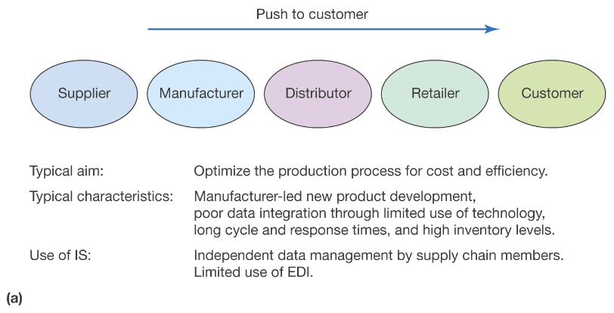

**Advantages of Push Strategy**

1. **Better Inventory Control**

A key advantage of a push strategy in a supply chain is better inventory control. Using the push strategy, manufacturers can produce products in advance, stock them, and then sell them with rising demand. This reduces the risk of stock-outs. Notably, stock-outs can lead to lost sales and customer frustration. Further, manufacturers can also reduce the risk of overstocking and related costs by using a push strategy.

1. **Forecasting Accuracy**

A push strategy in the supply chain helps manufacturers have a better understanding of demand patterns. Using the push strategy, manufacturers can have a more accurate view of the market. This leads to improved forecasting accuracy. Improved forecasting accuracy is crucial for effective planning and decision-making.

1. **Reduced Lead Time**

Another advantage of a push strategy in the supply chain is that it can reduce lead times. In this strategy, customers receive the products faster as products are produced and stocked even before the customer places an order. This can be particularly beneficial in today’s fast-moving markets where customers are looking for quick and reliable delivery.

1. **Alignment of Supply and Demand**

A push strategy can help align supply and demand in a better way. This reduces the risk of obsolescence. Using a push strategy in the supply chain, manufacturers can respond quickly to changes in demand and make necessary adjustments to production and inventory levels.

1. **Focus on Standard Products**

A push strategy in the supply chain can allow manufacturers to focus on producing standard products in high volume. This will help in reducing costs and improve efficiency. As production processes can be streamlined using a push strategy, the production of standard products will increase.

**Limitations of Push Strategy**

1. **Customer Demand Variability:**

In a push strategy, products are manufactured based on forecasts and pushed into the market. However, unpredictable changes in customer demand can lead to inventory imbalances and excess stock. This challenge highlights the importance of accurate demand forecasting and the need to adapt quickly to dynamic market conditions.

1. **Inventory Management:**

Push strategy relies on maintaining high inventory levels to meet anticipated demand. However, this approach can result in carrying costs, product obsolescence, and the risk of stockouts. Effective inventory management techniques, such as just-in-time (JIT) inventory, can help address these challenges by minimizing holding costs and optimizing stock levels.

1. **Production Planning:**

Aligning production capacity with anticipated demand is a crucial aspect of push strategy. Insufficient production capacity can lead to delays and missed delivery deadlines. Implementing efficient production planning processes, such as capacity analysis and resource optimization, can enhance production capabilities and minimize bottlenecks.

1. **Information Sharing in the Supply Chain:**

In a push strategy, effective communication and information sharing among supply chain partners become critical. Lack of real-time data exchange and collaboration can lead to inaccurate forecasts, delayed responses, and inefficient operations. Embracing technology-driven solutions like integrated information systems and collaborative platforms can foster seamless communication and enhance overall supply chain performance.

**Real-world examples of Push Strategy**

1. FMCG (Fast Moving Consumer Goods) companies such as Unilever and Coca-Cola use a push strategy in their supply chain management. They predict consumer demand for their products and then push their inventory to retail stores and meet the increasing demand.
2. Toy manufacturing company Lego uses a push strategy very effectively. They anticipate consumer demand for certain toys during holidays and peak periods and use a push strategy in their supply chain management to produce in-demand products in high volume.
3. Book publishers such as Penguin Random House, HarperCollins, and Simon & Schuster use a push strategy in their supply chain management. These publishers forecast the demand for new releases and stock their inventory in bookstores and online retailers even before the releases are available for readers to buy.

**—----------------------**

**Pull SCM-**emphasis delivery of values to customers who actively involved in product and service specification

Under the pull supply chain, the manufacturing and supply process is driven by actual customer demand. In this type of supply chain logistics, inventory is acquired on a need basis. This type of planning benefits includes less wastage in the case of lower demand. The problem, however, is that the company might not have enough inventory to meet rising demands due to unforeseen factors. For example, an auto repair shop only orders the parts it needs. In this case, the business waits until it gets an order to procure the parts required for the repair.

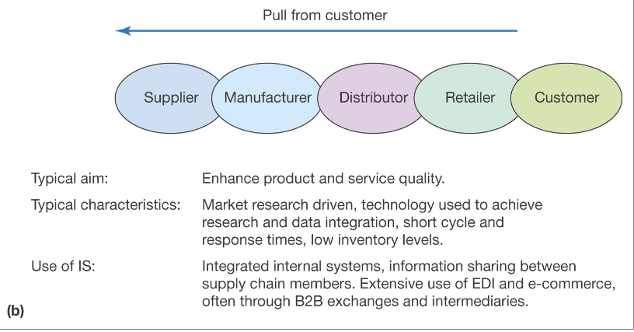

**Advantages of Pull Strategy**

1. **Enhanced Customer Relationships**

Satisfied customers are the lifeline of any business. A pull strategy in supply chain management can help businesses build strong, long-lasting relationships with their customers. Businesses can use a pull strategy to demonstrate a commitment to customer satisfaction by quickly and accurately fulfilling customer demand. This can lead to increased customer loyalty and customer requisition rate.

1. **Dynamic Response to Customer Demand**

One of the key benefits of a pull strategy is that it allows businesses to respond dynamically to changing customer demand. This strategy helps manufacturers closely monitor customer behavior. It helps them to adjust production and delivery. Pull strategy helps businesses to survive even in a highly competitive market.

1. **Better Quality Control**

With a pull strategy in the supply chain, businesses can take a more hands-on approach to quality control. In a pull strategy, businesses only produce products when they are needed. This allows businesses to produce only high-quality products.

1. **Sustainable Supply Chain**

A pull strategy in supply chain management can help businesses reduce waste, minimize surplus inventory, and improve overall sustainability. Businesses produce products as they are needed using a pull strategy. Further, using this strategy, manufacturers can closely monitor demand and reduce their environmental impact.

1. **Better Resource Allocation**

A pull strategy in supply chain management can help businesses allocate their resources more effectively. Businesses using this strategy are not tied up in surplus inventory or overproduction. They can also avoid the need for large amounts of working capital to support surplus inventory. This can result in improved cash flow and resource utilization and save costs.

**Limitations of Pull Strategy**

1. **Order Fulfillment:**

In pull strategy, products are manufactured based on actual customer demand. However, managing order fulfillment efficiently poses challenges such as lead time reduction, ensuring product availability, and minimizing stockouts. Streamlining order processing, optimizing logistics networks, and implementing robust demand-driven replenishment systems can alleviate these challenges.

1. **Bullwhip Effect:**

The bullwhip effect refers to the amplification of demand fluctuations as they propagate upstream in the supply chain. This phenomenon can result in excessive inventory, inefficient resource allocation, and increased costs. Employing collaborative forecasting techniques, sharing real-time sales data, and fostering strong relationships with suppliers can mitigate the bullwhip effect and improve supply chain coordination.

1. **Technology and Automation:**

Leveraging technology in a pull strategy can enhance visibility, enable accurate demand sensing, and automate various supply chain processes. Integration of advanced technologies like Artificial Intelligence (AI), Internet of Things (IoT), and predictive analytics can enable real-time demand monitoring, efficient order processing, and proactive inventory management.

**Real-world examples of Pull Strategy**

1. Toyota is a well-known example of a company that uses a pull strategy in its supply chain management through Just-in-Time (JIT) manufacturing. Instead of producing large quantities of a product ahead of time and storing it in a warehouse, JIT manufacturing produces products only when there is an actual demand for them. This approach helps reduce inventory costs and waste. This pull strategy also helps in increasing efficiency by only producing what is needed.
2. Many companies, such as UPS and FedEx, use a pull strategy in their reverse logistics operations. These companies pick up returned products from customers only after they have placed a return request. This helps to reduce the amount of unnecessary transportation and handling of returned products. Using a pull strategy here also helps in minimizing the amount of inventory that needs to be stored in a warehouse.
3. Companies like Vistaprint use a pull strategy. They produce printed products, such as t-shirts and business cards, only after a customer places an order. This helps to reduce waste and the cost of maintaining a large inventory.

**11. Use of e-business to restructure supply chain,**

1. A SCM can be viewed from control perspective-internal and external.
2. Vertical integration—supply chain activities are undertaken and controlled by the organization
3. Virtual integration—majority of supply chain activities are undertaken and controlled by third party

(Ques10 ka ans hai)

Supply Chain Management can be viewed as a continuum between internal control of supply chain elements and external control of supply chain elements through outsourcing.

The two end elements of continuum are usually referred to as ‘vertical integration’ and ‘virtual integration’.

The intermediate situation is sometimes referred to as ‘vertical disintegration’ or ‘supply chain disaggregation’.

This continuum is illustrated in the following figure:

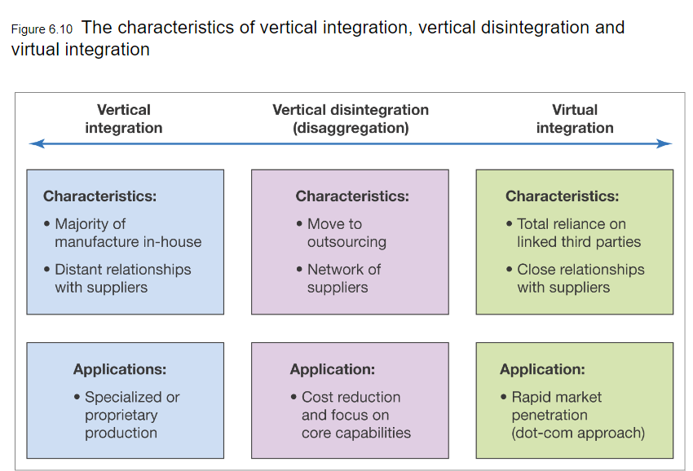

There was a general trend during the second half of twentieth century from vertical integration through vertical disintegration to vertical integration.

There has been a gradual move to sourcing more and more components to third parties.

Marketing activities such as website development, brochure fulfillment and advertising campaigns are now largely outsourced to marketing agencies.

Hayes and Wheelright provide a useful framework that summarizes choices for an organization’s vertical integration strategy. The three main decisions are:

a. The direction of any expansion: Should the company aim to direct ownership at the upstream or downstream supply chain? This is sometimes referred to as an offensive strategic move since enables the company to increase its power with respect to customers.

b. The extent of vertical integration: How far should the company take downstream or upstream vertical integration? Originally car manufacturers had a high degree of vertical integration, but more recently they have moved from a wide process span to a narrow process span.

c. The balance among the vertically integrated stages: To what extent does each stage of the supply chain focus on supporting the immediate supply chain? For example, if a supplier to a motor manufacturer also produced components for other industries this would be an unbalanced situation.

Combining these concepts, we can refer to the B2B Company. If it owned the majority of the upstream and downstream elements of the supply chain and each element was focused on supporting the activities of The B2B Company, its strategies would b to follow upstream and downstream directions of vertical integration with a wide process span and a high degree of balance.

Alternatively, if the strategy were changed to focus on core competencies it could be said to have a narrow process span.

**Electronic commerce support for these strategies:**

a. Through increasing the flow of information between the members of supply chain, a strategy of narrow process span can be supported by e-commerce.

b. However this relies on all members of the supply chain being e-enabled.

c. If only immediately upstream suppliers have adopted e-commerce then the efficiency of supply chain as a whole will not be greatly increased.

d. Companies undertaking offensive or defensive strategies will be in a better position to stipulate adoption of e-commerce, and so increase the overall efficiency of the supply chain.

**12. Supply chain management implementation**

**13. Procurement: Meaning and advantages of e –procurement,**

The electronic integration and management of all procurement activities including purchase request, authorization, ordering, delivery and payment between a purchaser and a supplier.

**The 5 rights of e-procurement:**

1. at the right price
2. delivered at the right time
3. are of the right quality
4. of the right quantity
5. from the right source.

E-procurement, or electronic procurement, is a digital transaction process that involves using the internet to buy and sell goods and services. This process employs a supplier's closed system, meaning that only their registered customers can use and gain benefits from it. Implementing e-procurement creates a direct connection between the supplier and buyer, helping to streamline business-to-business (B2B) or business-to-consumer (B2C) processes like emails, invoices, purchase orders and bids. Since e-procurement is an online business measure, it uses networked systems and web interfaces for supply chain operations.

The e-procurement process is a development of the 1980s, having spawned from the introduction of Electronic Data Interchange (EDIT), a method that describes the transference of data and information from one system to another. With EDI principles, e-procurement enables companies to generate online catalogs for their suppliers. This process involves elements like contract management and supplier evaluation. There's also specialized e-procurement software that you can leverage to automate B2B engagements between the supplier and company.

**Benefits of e-procurement**

1. **Creates information transparency:** E-procurement makes the transference of information and data more transparent to the company and its supplier. You can use this information to view purchasing behaviors, leverage buying power, control non-compliant spending, and identify opportunities to consolidate suppliers.
2. **Helps companies save money:** E-procurement can help a company save substantial amounts of money because it eliminates costly errors that may occur when handling manual orders and paperwork. The company can then use the money they save for other initiatives, like marketing and advertising.
3. **Automates procurement processes:** By automating your procurement processes, you're able to sustain more consistent and cost-effective operations. There's a diverse range of procurement software that you can use to help you achieve this goal, helping lower the need to perform monotonous activities, like data entry and analytics.
4. **Shortens procurement and purchasing cycles:** The benefit of shorter process cycles is that you're able to obtain the goods and services that you need at a much faster rate. This helps to limit operation downtime, which ultimately helps to increase productivity, save costs and increase profits.
5. **Improves inventory management and control:** It's important for a company to better manage their inventory because it enables them to gather accurate information about their current supply of goods. They can then use this information to make more informed business decisions.
6. **Streamlines operations:** This is an essential benefit of using e-procurement because it helps you save time and increases productivity. Having all of your online purchasing and selling processes functioning seamlessly creates a more uniform system and makes it easier to identify and resolve problems before they escalate.
7. **Larger product and service selection:** Because all the transaction and procurement processes occur online, you have access to a broader range of products and services to choose from. This variety enables you to make comparisons between what's available and select the goods that are best for your company and most cost-effective.
8. **Limits maverick spending:** Maverick spending describes when an individual procures products that aren't within the parameters of the designated contract and negotiations. Limiting these types of actions helps to ensure that all procurement processes meet compliance regulations set between the company and supplier.

**14. Types & Drivers of e- procurement,**

**Types of procurement**

1. Production-related procurement
2. Non-production related procurement

**How items are bought:**

* Systematic sourcing
* Spot sourcing

**Drives of e-procurement**

1. Cost reduction
2. Enhanced budgetary control
3. Elimination of administrative errors
4. Increasing buyer’s productivity
5. Improving information management
6. Improving the payment process

**15. Components of e-procurement systems,**

Components of electronic procurement

Electronic procurement involves various activities for businesses to select the most suitable materials for their production. Here's an overview of some components of electronic procurement:

1. **E-informing**

This is the first stage of electronic procurement and occurs before purchasing the relevant good or services. E-informing is exchanging purchase data between relevant internal and external parties. It involves determining the needs of a business by assessing its various production units or departments. It also includes determining which information the company can share with suppliers and reviewing information to ensure it's sufficient and credible. E-informing involves ensuring the data reaches the suppliers to facilitate a seamless supply process. It's essential for businesses using enterprise resource planning.

1. **E-tendering**

E-tendering involves exchanging relevant contract documents through electronic means, like emails or other information management systems. This process also occurs before the purchase of the relevant goods or services. Under this process, the business and suppliers exchange documents containing details, like product specifications, design instructions, and order details. E-tendering helps simplify the tendering process, which can be long and cumbersome when using paper-based methods. In addition to easing communication between suppliers and businesses, e-tendering also ensures greater accuracy of information, as many e-tendering systems use specific sections and questions to obtain information that the buyer requires.

1. **E-auctioning**

E-auctioning is bidding for various goods through the internet. Under this process, the supplier gathers interested buyers on a predetermined electronic platform to engage in competitive bidding for products of their choice. This process forms a part of procurement where buyers advertise their contracts to potential suppliers. E-auctioning offers many benefits over traditional auctioning, including greater transparency, enabling more parties to participate in the auction, and easier completion of post-auction processes. There are various methods of e-auctioning that businesses can adopt, depending on its needs.

1. **Vendor management**

Vendor management is a process through which businesses manage suppliers to improve the quality of products they receive. This process is an essential part of procurement, as it enables businesses to control product quality, cost, risks, and service delivery. Usually, the supply chain unit responsible for managing contracts also caters to vendor management. This process includes conducting research into market prices and available product quality. It also involves maintaining good relationships with vendors by providing frequent feedback and ensuring prompt payment for services. Vendor management is essential to help ensure business processes continue smoothly.

1. **Catalogue management**

A catalogue contains details about a supplier's products or services. These documents contain prices, product specifications, warranties, and relevant buyer policies. Catalogue management is the process of ensuring the accessibility, quality, and accuracy of a supplier's catalogue. Effective catalogue management aids electronic procurement, allowing buyers to review products without frequent communication with the supplier. Suppliers can host their catalogues on business websites or third-party applications.

1. **E-purchasing**

E-purchasing is the process of buying products online. This term usually applies when businesses purchase low-value products in large quantities. Usually, these products don't have complex details or specifications and don't require the tendering of documents. In e-purchasing, buyers can access the supplier's catalogue online and make orders for the type and quantity of products they require for a business. E-purchasing encompasses the process of selecting items, making an order, processing payment, and tracking delivery. E-purchasing systems are usually complex software that can handle these processes.

1. **E-ordering**

E-ordering is the aspect of electronic procurement involving the approval and management of purchase orders. It includes all processes from making an order to receiving the products. Under electronic procurement, special software handles the process of e-ordering, improving the efficiency of the business' supply chain. Usually, this software is accessible to all relevant employees, allowing various departments access to the resources they require to function.

1. **E-invoicing**

E-invoicing involves processing and exchanging invoices through electronic means. Usually, the same software that handles catalogue management, e-purchasing, and e-ordering also caters to e-invoicing. After the buyer selects the products they want and orders, the software can automatically generate an invoice and forward it to the buyer for payment. In large companies, the accounts payable department reviews the invoices it receives and ensures proper processing and prompt payment.

1. **E-contract management**

This involves managing all relevant contract documents in the procurement process, including creating, editing, and settling contracts. E-contract management allows businesses to process multiple contracts effectively and without spending on paper and employees. E-contract management also enables companies and suppliers to conclude on contracts remotely, improving efficiency and transparency.

**16. Implementation of eprocurement**

* Stock control system
* CD/web-based catalogue
* E-mail/workflow system
* Order-entry on web site
* Accounting systems
* ERP systems

